CHAPTER 15: THE DEVICE-INDEPENDENT BITMAP

From DDB to DIB (Why DIBs Exist)

In Windows GDI, a bitmap is usually a **Device-Dependent Bitmap (DDB)**.

A DDB is made for **drawing to the screen**.  
It works fast — but it has a big problem.

A DDB depends on the **current display device**.

If you save it to disk and load it later, or move it to another computer:

* colors may change
* pixel format may break
* it may not load correctly

So DDBs are **bad for storing images**.

To solve this, Windows introduced the **Device-Independent Bitmap (DIB)** in Windows 3.0.

A DIB is made for **storage, memory, and exchange**, not just drawing.

DDB vs DIB (Simple Comparison)

I. DDB (Device-Dependent Bitmap)

* Tied to the display device
* Format depends on video hardware
* Not safe to save or reload
* Good only for fast drawing

II. DIB (Device-Independent Bitmap)

* Independent of the display
* Stores pixels + color info together
* Looks the same everywhere
* Safe to save, load, and share

III. Short version:

* DDB → screen
* DIB → memory and files

Why DIBs Are Useful

I. Built for the Windows API

Windows understands DIBs directly.

You can:

* load them into memory
* modify pixels
* display them
* convert them to DDBs for drawing

No external image decoders.

II. Lossless Pixel Data

DIBs are usually **uncompressed**.

That means:

* no quality loss
* exact pixel values

This matters for:

* image editing
* analysis
* learning how graphics really work

III. Full Control

DIBs store **raw pixel memory**.

You can:

* edit pixels directly
* change colors or palettes
* write your own image algorithms

This is hard to do with formats like JPEG or GIF.

IV. Key Takeaway

* **DDB** → fast drawing, bad for saving
* **DIB** → best for storing and manipulating images
* DIBs trade file size for **control and correctness**

That’s why serious GDI image work always ends up using DIBs.

DIBs Today **🧱**

DIBs are not made for the web — and they don’t need to be.

They are used when writing:

* image editors
* graphics or CAD tools
* visualization software
* low-level WinAPI programs

Why?

* native Windows support
* raw pixel access
* predictable behavior

Big files. Old format. Still powerful.

I. DIB File Format (Just the Facts)

* Origin: OS/2 1.1 (Presentation Manager bitmap)
* Windows: adopted in Windows 3.0 (1990)
* Never replaced, never removed

This is why WinAPI graphics still feel **bitmap-first**.

II. Core Characteristics

* Extensions: .BMP, .DIB
* Color data stored inside the bitmap
* Stored in memory as a **packed DIB**  
  (header + color table + pixels)
* Strong WinAPI support
* Easy to process manually

This is why low-level devs and reverse engineers like it.

III. Where DIBs Are Used

* Application images
* Icons and cursors
* Clipboard image transfer
* Custom GDI brushes
* Image processing and experiments

If you touch **GDI, BitBlt, StretchBlt, or raw pixels**, you’re already using DIBs.

IV. Remember this

A DIB is:

**A block of memory that Windows understands as pixels.**

No compression.  
No surprises.  
No device dependency.

V. File Structure: How the Data is Organized

A DIB file (like a .BMP) is organized into four main parts:

* **File Header (14 bytes):** The "ID card" of the file. It tells the computer this is a bitmap, how big the file is, and where the actual image data starts.
* **DIB Header:** This contains the image details. It stores the width, height, how many colors it uses, and if the image is compressed.
* **Color Table (Optional):** Used if the image has a limited palette (like 256 colors). It’s a list that maps numbers to specific colors.
* **Pixel Data:** The actual image. It stores the "dots" (pixels) that make up the picture, usually uncompressed so the quality stays perfect.

VI. Working with DIBs in Memory

* **Packed-DIB Format:** When a program opens a DIB, it often puts the header and pixel data into one continuous block of memory. This makes it faster for the computer to process.
* **Creating from Scratch:** Developers don't just open files; they can create a DIB directly in the computer's memory to build an image from scratch.

VII. Windows & Custom Programming

* **Windows API:** Windows has built-in tools to help display these images on screens/printers or convert them into other formats.
* **Custom Coding:** If you want to do advanced stuff—like adding artistic filters, changing color depth, or high-end editing—you usually have to write your own custom code rather than relying on the basic Windows tools.

VIII. Deep Dive: OS/2-Style DIB Format

This is an older, simpler version of the bitmap format. Here is exactly what is inside:

File Header (14 bytes)

* **bfType:** Must be the letters "BM".
* **bfSize:** Total size of the file.
* **bfOffBits:** How many bytes you have to skip to get to the actual image data.

Information Header (12 bytes)

* **bcWidth / bcHeight:** The size of the image in pixels.
* **bcBitCount:** How many "bits" per pixel (1, 4, 8, or 24). This determines the color quality.

The Pixel Bits (How colors are stored)

The way the computer reads the image depends on the **Bit Count**:

* **1-bit:** 1 byte holds 8 pixels (Black & White).
* **4-bit:** 1 byte holds 2 pixels (16 colors).
* **8-bit:** 1 byte holds 1 pixel (256 colors).
* **24-bit:** 3 bytes hold 1 pixel (Full "True" Color using Red, Green, and Blue).

**Key Takeaway:** DIBs are great because they work the same way on any screen or device. While Windows provides the basics, programmers can manipulate the raw data to do almost anything with the image.

IX. Code Examples

Allocating memory for an 8-bit DIB information structure:



Accessing a color table entry:

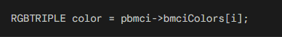

X. Simplified Key Points:

* OS/2 DIBs support 1, 4, 8, or 24 bits per pixel.
* Color tables are used only with 1-, 4-, and 8-bit images.
* Pixel data layout depends on the bit depth.
* Important colors should appear first in the color table.
* Pixel data always starts on a WORD-aligned boundary.

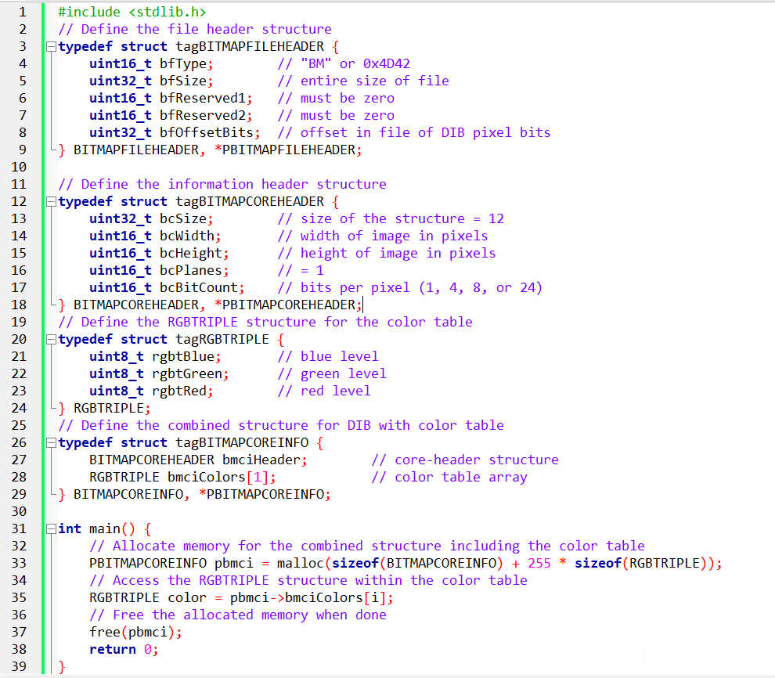

This code works with bitmap image headers and related data structures. It starts by including **<stdlib.h>**, which provides functions for dynamic memory management like malloc() and free().

After that, the code defines several structures that model different sections of a bitmap image file.

**BITMAPFILEHEADER** - Defines the basic file-level information for a bitmap, including the file type, total size, and where the pixel data begins.

**BITMAPCOREHEADER** - Stores the core image details such as width, height, color planes, and bits per pixel (1, 4, 8, or 24).

**RGBTRIPLE** - Represents a single color entry in the bitmap’s color table using red, green, and blue values.

**BITMAPCOREINFO** - Combines the core header with a color table, forming a complete OS/2-style DIB structure.

In main(), memory is dynamically allocated for a BITMAPCOREINFO structure along with space for the full color table.

The code then accesses entries in the color table (though the index variable is missing in the snippet) and finally frees the allocated memory.

DIB Pixel Order (Bottom-Up)

DIBs store pixel rows **bottom-up**, not top-down.

* The **first row in the file** is the **bottom row of the image**
* The **last row in the file** is the **top row of the image**
* **Top / Bottom rows** → how the image appears visually
* **First / Last rows** → how rows are stored in the file

I. Why This Happens

* OS/2 used a coordinate system where **Y increases upward**
* DIBs followed this system for consistency with OS/2 graphics
* Result: bitmap data is written from bottom to top

II. Practical Impact

* When reading or writing DIBs, **rows must be handled in reverse**
* Image processing code may need to flip rows
* This behavior is normal and expected for classic DIB formats

DIBs are bottom-up by design.  
Always account for reversed row order when accessing pixel data.

DIB Pixel Data Layout

I. Pixel storage rules in DIBs:

* **Bottom-up order:**  
  Pixel rows are stored from the bottom of the image to the top.
* **Left-to-right order:**  
  Pixels within each row are stored from left to right.
* **Row padding:**  
  Each row is padded with zero bytes so its size is a multiple of **4 bytes**.

II. Why This Matters

* Code must read rows in reverse to display the image correctly.
* Padding bytes must be skipped when moving between rows.

DIB pixel data is stored **bottom-up**, **left-to-right**, with **4-byte row alignment**.

Bit Depth Guides Pixel Encoding

1-bit DIBs (Simple Black and White):

Every byte oversees 8 pixels. The leftmost pixel takes the lead by claiming the top bit. Pixel values of 0 or 1 map to the 2-color palette, deciding between the first or second color.



4-bit DIBs (16 Distinct Shades):

Each byte manages two pixels. The leftmost pixel controls the high 4 bits, and the second pixel sits in the lower 4 bits. Values from 0 to 15 guide color selection from the 16-color palette.

8-bit DIBs (256 Vibrant Tones):

Each byte represents a single pixel. Pixel values from 0 to 255 link to the 256-color palette, creating a canvas of 256 unique shades.

24-bit DIBs (True Color Bliss):

Each pixel enjoys 3 dedicated bytes for red, green, and blue. Rows turn into arrays of RGBTRIPLE structures, encapsulating color intensity. Padding remains key for optimal memory alignment.

A repeat of the above page for clarity:

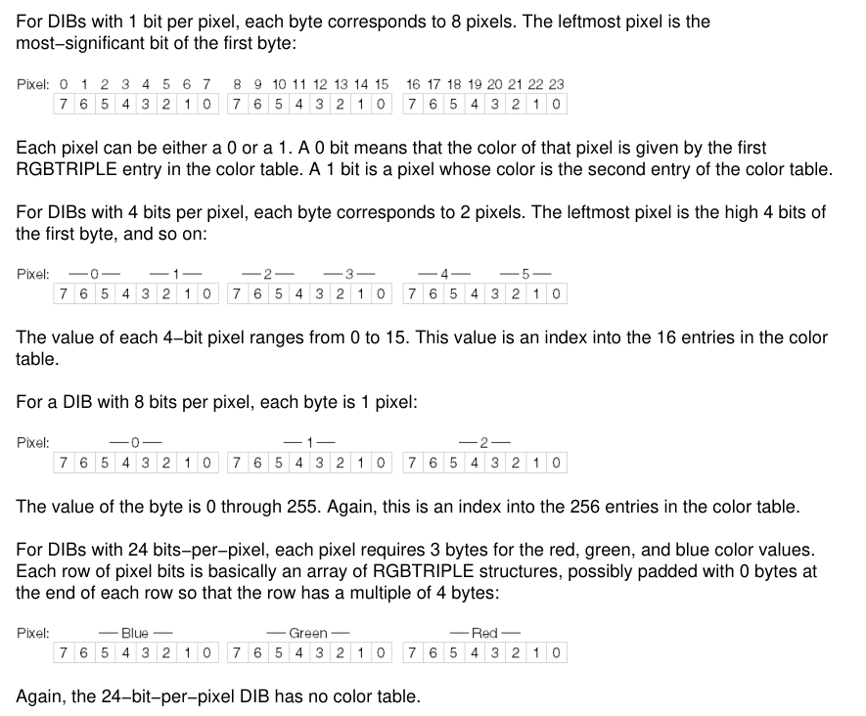

What the Diagram Shows

1. File layout  
The diagram shows how a DIB file is organized: the file header first, then the information header (and color table when used), and finally the pixel data at the end.

2. Pixel encoding by bit depth  
It also shows how pixels are packed depending on the bit count:

* **1-bit:** one byte holds 8 pixels
* **4-bit:** one byte holds 2 pixels (high nibble first)
* **8-bit:** one byte per pixel (color table index)
* **24-bit:** three bytes per pixel (RGB)

3. Bottom-up storage  
The diagram places the image’s bottom row first to reflect how DIBs store pixel data. This is normal for DIBs, even though it looks backwards compared to most image formats.

4. Working with DIB Pixels

Once you understand how pixels are stored, accessing and modifying them is straightforward. Pixel Access goes like:

* **Find the pixel:** Convert the row and column into a byte offset in the pixel data.
* **Read the value:** Extract the pixel data based on the image’s bit depth.

Pixel Modification

* **Change colors:** Update the pixel value directly (eg, flip bits to invert colors).
* **Apply filters:** Loop through pixels and apply calculations for effects like grayscale.
* **Transparency:** For formats with alpha data, adjust transparency along with RGB values.
* Each row may include padding bytes. Account for this when stepping through rows.
* Always check bounds to avoid invalid memory access.

The Windows DIB: Modern Enhancements

Windows 3.0 updated the DIB format to handle larger images and better performance. Here is the breakdown of the changes:

I. File Header

**No Change:** Still uses the same 14-byte BITMAPFILEHEADER as the OS/2 version.

II. Information Header (BITMAPINFOHEADER)

This is the biggest change. It grew from 12 bytes to **40 bytes** and added these features:

* **Larger Images:** Uses 32-bit values for width and height (allowing for much bigger resolutions).
* **Compression:** Added a field (biCompression) to allow compressed image data.
* **Image Size:** A new field (biSizeImage) specifically for the total byte count of the pixels.
* **Resolution:** Stores "pixels per meter" for horizontal and vertical printing accuracy.
* **Color Control:** Includes fields to show exactly how many colors in the palette are actually being used or are "important."

III. Color Table (RGBQUAD)

* **The Change:** Switched from RGBTRIPLE (3 bytes) to RGBQUAD (4 bytes).
* **The Reason:** The extra byte is "padding" that aligns the data to 32-bit boundaries, making it much faster for modern processors to read.

IV. BITMAPINFO Structure

* This is just a "wrapper" that combines the **Header** and the **Color Table** into one single unit for easier programming.

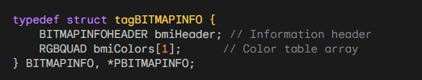

V. Key Summary Points

* **How to tell them apart:** Check the header size. **40 bytes** = Windows; **12 bytes** = OS/2.
* **Better Scaling:** Windows DIBs support larger dimensions and built-in compression.
* **Better Speed:** Uses 4-byte color entries to help 32-bit computers process data faster.
* **Better Printing:** Stores resolution data (pixels per meter) to ensure the image prints at the correct size.

The original Windows 3.0 DIB was simple. But as technology improved (scanners, high-res printers), the format had to evolve. Windows 95 and NT 4.0 took the standard BITMAPINFOHEADER structure and gave the fields new, specific meanings.

1. The Upside-Down Trick (biHeight)

In the classic math world (Cartesian coordinates), the "Y" axis goes **UP**. In the computer reading world (like reading a book), the "Y" axis goes **DOWN**.

* **Positive Height (e.g., 100):** The standard. The image is stored "Bottom-Up." The first byte of data represents the bottom-left pixel.
* **Negative Height (e.g., -100):** The modern twist. The image is stored "Top-Down." The first byte represents the top-left pixel.

**Why do this?** It makes it easier for video players and DirectX to blast memory straight to the screen without doing math to flip the image. *Note: You cannot compress a top-down DIB. It must be uncompressed.*

2. The "Real World" Size (biXPelsPerMeter)

A bitmap is just a grid of pixels (e.g., 100x100). But how big is it?

* On a smartwatch, 100 pixels is tiny.
* On a stadium jumbotron, 100 pixels is huge.

The fields biXPelsPerMeter and biYPelsPerMeter answer the question: **"If I print this, how many inches should it be?"**

**Standard Values:**

* 0: "I don't care. Make it whatever size you want."
* 2835: Approx 72 DPI (Standard Screen).
* 11811: Approx 300 DPI (Standard Print).

3. The Color Table Optimization (biClrUsed)

This is the most confusing field for beginners. Its meaning changes depending on the "Bit Depth" (how many colors the image has).

A. For "Palettized" Images (4-bit, 8-bit)

These images use a lookup table (Color Table).

* **Standard (biClrUsed = 0):** "I use the full table." (e.g., 256 colors for 8-bit).
* **Optimized (biClrUsed = 50):** "I have 256 slots available, but I only actually use the first 50 colors. Don't bother loading the rest."
* **Benefit:** Saves a tiny bit of file size and memory.

B. For "True Color" Images (16-bit, 24-bit, 32-bit)

These images usually store color directly in the pixel (Red/Green/Blue values) and **don't** need a table.

* **Standard (biClrUsed = 0):** "No table. Pure pixels."
* **Compatibility Mode (biClrUsed = non-zero):** "I am a True Color image, BUT here is a small list of the 'Most Important' colors in case you try to view me on an ancient 256-color monitor."

4. The "Priority" List (biClrImportant)

This field is rarely used today.

* It tells the system: "If you can't show all 200 colors, strictly prioritize the first X colors."
* **Rule of Thumb:** Just set it to 0 (meaning "All colors are important").

Explained Like I'm a Teenager: The Image Header

Think of a DIB File like a **container for a Lego set**. The Header is the instruction booklet.

1. **biHeight (Negative):** This is just deciding if you build the Lego set starting from the feet (Bottom-up) or the head (Top-down).
2. **biXPelsPerMeter:** This is the scale. Is this a miniature Lego set (High DPI) or those giant Duplo blocks (Low DPI)?
3. **biClrUsed:** This is the piece count.
   * The box says "Supports 256 colors!"
   * But if you only built a spaceship using Grey and Black, you write biClrUsed = 2. It tells the user "Don't bother looking for the pink bricks; they aren't in there."

Quick Review

**Question 1:** If biHeight is negative, where is the first pixel of data located in the image? *(Answer: The Top-Left corner. This is a "Top-Down" DIB.)*

**Question 2:** If you have a 24-bit image (millions of colors), why might you still include a Color Table? *(Answer: For backward compatibility. It helps older 256-color monitors pick the "best" colors to display the image roughly.)*

**Question 3:** What does biClrUsed = 0 mean for an 8-bit image? *(Answer: It means the full standard palette is used (2^8 = 256 colors).)*

Real-World DIBs (8-bit and Gray-shade).

In theory, DIBs are simple. In practice, you will encounter weird formats created by old software (like Windows 3.0 Paint) or specialized scanners. This section explains how to handle the two most common "ambiguous" types: **8-bit Gray-shade** vs. **8-bit Color**.

I. The 8-Bit Dilemma

The most common DIB you will find is **8-bit (256 colors)**. The problem? The header (BITMAPINFOHEADER) does **not** tell you if the image is **Color** or **Black & White**. You have to look at the **Color Table** to figure it out.

***a) Gray-Shade DIBs (The "Fake" Color)***

A grayscale image is just a color image where Red = Green = Blue.

* **64-Level Gray:** Some older scanners only captured 64 shades.
* **256-Level Gray:** The modern standard.

**How to Spot It:** You iterate through the Color Table. If R == G == B for every single entry, it is a grayscale image.

**The Code (Generating a Gray Table):** If you are creating a grayscale DIB manually, you need to calculate the palette entries. Here is the formula for a 64-level table:

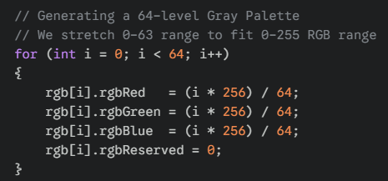

***b) Palettized Color DIBs***

These use the color table to store 256 specific colors (e.g., "Mustard Yellow", "Navy Blue").

**Full Table:** biClrUsed = 0 or 256. The image uses every slot.

**The "Safety" Table:** Sometimes you see biClrUsed = 236.

*Why?* Windows reserves 20 colors for system UI (borders, buttons). Old apps avoided overwriting these 20 colors to prevent the screen from flashing weird colors.

2. The Legacy Formats (Rare)

**OS/2 DIBs**

* **History:** Before Windows dominated, OS/2 (IBM) had its own bitmap format.
* **Difference:** The header structure is different (BITMAPCOREHEADER instead of BITMAPINFOHEADER).
* **Status:** Extremely rare today. Most modern code simply rejects them or converts them.

**4-Bit DIBs (16 Colors)**

* **History:** From the VGA era (Windows 3.1 Paint).
* **Status:** Surprisingly common in old clip-art libraries.
* **Logic:** Two pixels are packed into one Byte. You need bit-shifting logic (>> 4 and & 0x0F) to read the pixels.

3. The "Useless" Fields

When reading DIBs in the wild, you can usually ignore these fields in the header:

**biXPelsPerMeter / biYPelsPerMeter:**

* Almost always 0. Even if they have values (like 2835 for Screen Resolution), Windows GDI functions usually ignore them.

**biClrImportant:**

* Supposed to tell you "Only the first X colors matter." In reality, it is almost always 0 (meaning "All colors matter").

4. Summary Checklist (Developer's Note)

**Flag Missing:** There is no header flag for "Grayscale." You must infer it.

**Gray Math:** GrayLevel = (R + G + B) / 3.

**Validation:** Always check biClrUsed. If it is 0 on an 8-bit image, assume 256.

The Different "Types" of Images

Think of these like different quality settings for a photo:

* **8-bit:** The most common. It can show 256 different colors or shades of gray.
* **4-bit:** Old school and lower quality (only 16 colors). You’d see this in the original version of MS Paint.
* **OS/2-style:** Ancient tech. You’ll almost never see this today.

I. 8-Bit Grayscale (Black & White Photos)

This explains how a computer makes a black-and-white image:

* **The Color Table:** This is like a "paint-by-numbers" legend. It lists every shade of gray from pure black to pure white.
* **biClrUsed:** This is just a label that tells the computer how many shades of gray are in that legend (usually 256).
* **The Shortcut:** Because the shades are in order, the computer doesn't have to think hard—a pixel value of "0" is black, and "255" is white.

II. 8-Bit Color (Limited Color Photos)

Instead of shades of gray, this uses a specific set of 256 colors.

* **The Color Table:** Again, this is the "paint-by-numbers" legend, but with colors like Red, Blue, and Green.
* **The 236 Limit:** You might see the number **236** instead of 256. This is because old versions of Windows liked to "reserve" 20 colors for the system (like the colors of the taskbar and buttons), leaving only 236 for the actual picture.

III. Code Examples

Generating Gray-Shade Color Tables:

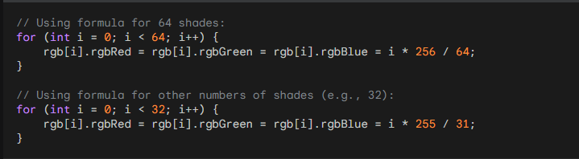

Accessing Pixel Values in Gray-Shade DIBs:

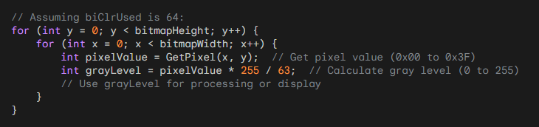

The "Useless" Labels

The text lists a few settings that most programmers just ignore:

* **PelsPerMeter:** This is supposed to tell a printer how many pixels fit in a meter. Almost everyone sets this to **0** because the computer usually doesn't care.
* **biClrImportant:** This asks, "Which colors are the most important?" Most people just put **0**, which means "they're all important."

I. Compression (The "Suitcase" Logic)

**Compression** is just a way to make a file smaller so it doesn't take up too much room on your hard drive.

**What is RLE? (The Shortcut)**

The text mentions **RLE (Run-Length Encoding)**. It’s a very simple trick.

* **Without RLE:** If you have 100 white pixels in a row, the computer writes: "White, White, White..." 100 times. (Waste of space!)
* **With RLE:** The computer just writes: **"100 White."** (Much smaller!)

II. Which Images Use Compression?

The notes are basically giving you a "rulebook" for different types of images:

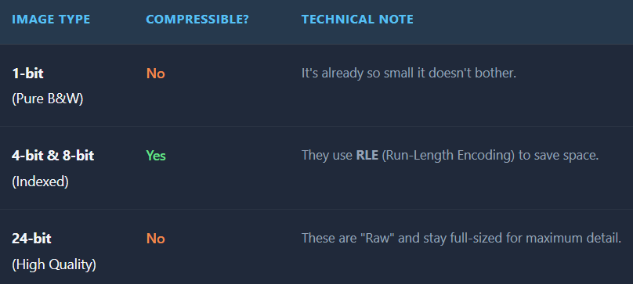

III. The "16-bit and 32-bit" Mystery

The text mentions **"color masking"** and **"BITFIELDS."** Don't let that confuse you—it’s just a fancy way of saying that for very high-quality images (like the ones on your phone today), the computer uses a "mask" to decide exactly how much Red, Green, and Blue to mix for every single pixel.

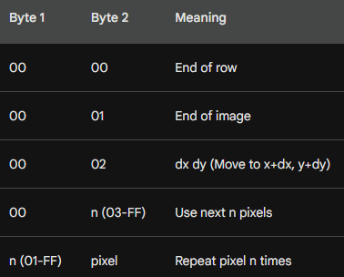

IV. What is this table?

The image shows the **"Escape Codes"** used in Windows bitmap compression (RLE).

When Windows compresses an image, it usually just says "Repeat this color 5 times." But sometimes, it needs to give a special command. It signals a command by setting the first byte to 00. The second byte tells the computer which command to execute:

* **00 00 (End of Row):** Stop drawing this line and move to the start of the next line.
* **00 01 (End of Image):** Stop! The whole picture is finished. Do not read any more data.
* **00 02 (Jump):** Don't draw anything. Just move the "cursor" right by X pixels and down by Y pixels (skipping over a blank spot).
* **00 n (Absolute Mode):** Don't repeat anything. Just copy the next n pixels exactly as they are.

Compression & RLE

**The Concept: Run-Length Encoding (RLE)** Imagine you have a picture of a blue sky. Instead of saving "Blue pixel, Blue pixel, Blue pixel..." a million times, RLE saves "1,000 Blue pixels." This makes the file much smaller.

I. How 8-bit Compression Works (BI_RLE8)

The computer reads the data in pairs (2 bytes at a time). It looks at the **First Byte**:

* **If the First Byte is a Number (e.g., 5):** This is "Repeat Mode." It means: "Take the color in the *second* byte and draw it 5 times."
* **If the First Byte is Zero (00):** This is "Command Mode." The *second* byte tells the computer to do something special (like stop the line or jump ahead), as shown in the table above.

II. How 4-bit Compression Works (BI_RLE4)

This is the "Hard Mode." In a 4-bit image, one byte holds **two** pixels.

* If you say "Repeat 5 times," the computer has to alternate the colors inside that byte.
* *Example:* If the color byte is Blue/Red, and you repeat it 3 times, you get Blue, Red, Blue. It is confusing math, so most programmers avoid 4-bit compression if they can.

III. The "Transparent" Trick (Delta)

The code 00 02 is a "Jump" command. It tells the computer to skip pixels without drawing anything. This allows you to create non-rectangular images (like a circular character sprite) where the background is transparent because you simply "skipped" drawing it.

IV. The Header Fields (biCompression)

The Header tells Windows which language to speak when opening the file:

* **BI_RGB:** "Raw." No compression. The file is large, but easy to read.
* **BI_RLE8:** "Compressed 8-bit." Use the rules above.
* **BI_BITFIELDS:** "Masking." Used for advanced 16-bit or 32-bit colors (we will discuss this later).

V. Important Limitation

**No Top-Down Compression:** If you made your image "Upside Down" (by setting biHeight to a negative number), Windows refuses to compress it. You can only compress standard "Bottom-Up" images.

VI. Code Example (8-bit RLE Decoding):

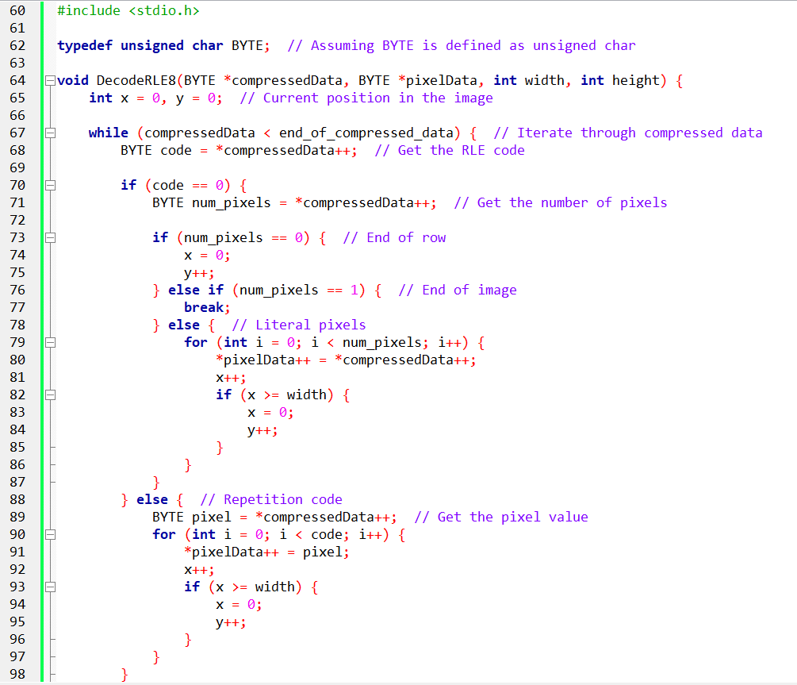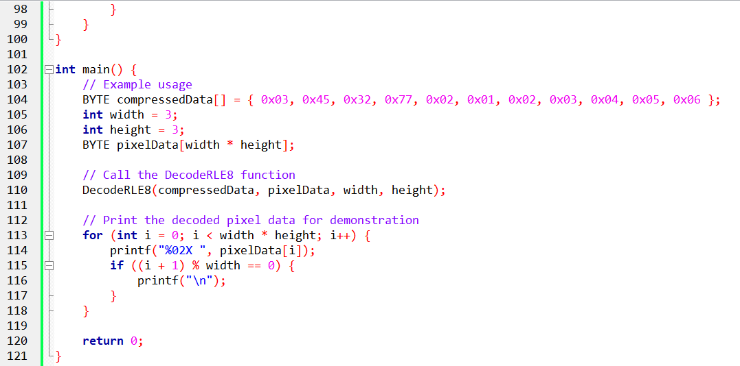

Pg 585 book.

DIB Structure and Color Masking.

This section explains how Windows packs three colors (Red, Green, Blue) into a single number (a Pixel).

I. The Container (The DIB Structure)

A DIB (Device Independent Bitmap) is just a file that holds a picture. It has two parts:

1. **The Header (BITMAPINFOHEADER):** The ID Card. It tells you "I am 100 pixels wide, and I use 16-bit color."
2. **The Pixel Data:** The actual dots.

The tricky part is the **Header**. Specifically, the field biCompression. This field tells the computer: *"Here is how to slice the pixel data to find the Red, Green, and Blue values."*

II. The Problem: "Smashing" Colors

In a perfect world, every pixel would have 3 separate bytes: one for Red, one for Green, one for Blue. But computers want to save space. So, they "smash" these colors together into a single integer.

**Color Masking** is the mathematical tool we use to "un-smash" them.

* **The Mask (&):** A filter that ignores everything except the color we want.
* **The Shift (>>):** Moving the data to the right place so we can read it as a number.

III. Scenario A: 16-Bit Color (BI_RGB)

**"The 5-5-5 Format"** This format was popular in the 90s (Windows 95/98) to save RAM.

**Total space:** 16 bits (2 bytes).

**The Layout:** 1 bit is wasted. Then 5 bits for Red, 5 for Green, 5 for Blue.

* X RRRRR GGGGG BBBBB

**How to extract the Red:**

1. **The Mask:** The computer applies the Hex mask 0x7C00. This is binary code for "Keep the Red bits, delete the rest."
2. **The Shift:** The Red bits are stuck on the left side (high values). We shift them right by 10 spots (>> 10) to move them to the "ones" place.
3. **The Scaling:** 5 bits only gives us numbers from 0 to 31. But modern screens want 0 to 255. So, we multiply the result (Shift Left << 3) to stretch the brightness to the full range.

IV. Scenario B: 32-Bit Color (BI_RGB)

**"The Luxury Format"** This is the standard today. We don't care about saving space; we want speed.

**Total space:** 32 bits (4 bytes).

**The Layout:** 8 bits for Red, 8 for Green, 8 for Blue, and 8 wasted (or used for Alpha transparency).

* 00000000 RRRRRRRR GGGGGGGG BBBBBBBB

**How to extract the colors:** It is much easier because nothing is "smashed" together tightly. Every color gets its own full byte.

* **Blue:** It's already at the bottom. Just Mask it (0x000000FF). No shifting needed.
* **Green:** It's in the middle. Mask it (0x0000FF00) and shift it right 8 spots (>> 8).
* **Red:** It's at the top. Mask it (0x00FF0000) and shift it right 16 spots (>> 16).

V. Explaining Like I'm a Teenager: The Combination Lock

Imagine a pixel is a 3-digit combination lock, like **"9-5-2"**.

* **9** is Red.
* **5** is Green.
* **2** is Blue.

But the computer stores it as the single number **952**.

1. **Masking:** If I ask "How much Red is there?", I cover up the "52" with my thumb. Now I only see "900".
2. **Shifting:** "900" is the wrong number. The value is just 9. So I "shift" the decimal point two spots to turn 900 into 9.

That is exactly what Windows does with binary bits (0x7C00 and >> 10).

VI. Quick Review

**Question 1:** In 16-bit BI_RGB (5-5-5) format, why do we shift the Red value right by 10 bits? *(Answer: Because the Red bits are stored at the top of the 16-bit word. We need to move them to the bottom to read them as a normal number.)*

**Question 2:** Why is 32-bit color easier for the computer to handle than 16-bit? *(Answer: The colors align perfectly with bytes (8 bits). The computer doesn't have to do as much complex bit-shifting math.)*

**Question 3:** What is the purpose of "Masking"? *(Answer: To isolate specific bits (like the Red channel) and ignore the others (Green/Blue) inside a packed integer.)*

BI_BITFIELDS

I. The “Mask” (Think: A Stencil)

Imagine you spilled **red, green, and blue paint** all over a piece of paper.

Now imagine you take a **cardboard stencil** that only has holes where the **red paint** is.

* When you place that stencil on the paper, you **only see red**.
* Everything else is blocked out.

That stencil is what computers call a **mask**.

When a computer uses a **Bitwise AND**, it’s doing the same thing:

*“Show me only the parts I care about. Ignore everything else.”*

So, a **Red Mask** means:

“From this number, only keep the bits that represent red.”

Nothing magical — just selective vision.

II. Shifting (Moving Things into the Right Spot)

After using the stencil, the color you found is often **not sitting where you want it**.

It’s like finding a word in a sentence, but it’s way off to the right.

So, we *move it*.

**Right Shift (>>)**

* This is like sliding the color **all the way to the left** so you can read it easily.
* Think: *“Move this number into position so I can understand it.”*

**Left Shift (<<)**

This makes the number **bigger and stronger**.

* It’s like turning up the volume.
* Or making the color brighter so it fits the normal **0–255 range** that programs like Photoshop expect.

So:

* **Right shift = move into place**
* **Left shift = scale it up**

III. The Example (The Number 0xABCD)

Let’s walk through the example in plain English.

**1. The Box**

You start with a pixel number:



This single number secretly holds **red, green, and blue** all packed together.

**2. The Stencil**

You grab the **Red stencil**:



This stencil knows exactly where the red bits live.

**3. The Cutout**

You place the stencil on the number.

Now:

* You **only see the red bits**
* Everything else is gone

This is the **masking** step.

**4. The Slide**

Those red bits are still sitting off to the side.

So, you **slide them right**:



Now the red value is neatly lined up and easy to read.

**5. The Scale**

The red value is still a bit small.

So, you **scale it up**:



Now it matches the normal color range. Final result:



IV. Why Do We Even Do This?

Normally, computers follow **standard color layouts**.

But sometimes a programmer wants to:

* Pack colors differently
* Use fewer bits
* Put blue first instead of red
* Save memory
* Match special hardware

That’s where **BI_BITFIELDS** comes in.

It’s basically the computer saying:

“Hey, this image doesn’t follow the usual rules.  
Here’s a custom map showing where each color lives.”

So BI_BITFIELDS is just a **custom instruction manual** for how colors are packed inside a number.

32-bit DIB (BI_RGB) — Extracting Colors the Easy Way

This time, things are **much simpler** than BI_BITFIELDS.

In a **32-bit BI_RGB image**, the computer follows a fixed rule. No guessing, no custom layouts.

I. How One Pixel Is Stored (The Layout)

Each pixel uses **4 bytes** (32 bits total).

They are always arranged like this:



Think of it as four boxes in a row:

* **RR** → Red
* **GG** → Green
* **BB** → Blue
* **00** → Extra byte (unused, always zero)

So, when you see a pixel number, all three colors are already neatly separated into their own byte.

No scaling. No stretching. No tricks.

II. Masks and Shifting (Same Tools, Easier Job)

We still use **masks** and **shifts**, but now it’s straightforward because:

* Each color already fits in **8 bits (0–255)**.
* We only need to **move the right byte to the front**.

**Extracting Red**

Red is stored in the **last byte** (RR).

So, we:

1. Mask everything except the last 8 bits
2. Done — no shifting needed



Think:

“Keep the last box. Throw away the rest.”

**Extracting Green**

Green is in the **middle byte**.

So, we:

1. Slide the number **right by 8 bits**
2. Mask the last 8 bits



Think:

“Slide green to the end, then grab it.”

**Extracting Blue**

Blue is in the **third byte from the right**.

So, we:

1. Slide right **16 bits**
2. Mask the last 8 bits



Think:

“Slide blue all the way over, then grab it.”

III. Walkthrough Example (Real Numbers)

**Pixel Value**



Break it into bytes:



So visually:

* **Red** = 0x58
* **Green** = 0xE0
* **Blue** = 0x48

**Red Extraction**



Result: Red = 0x58

**Blue Extraction**



Result: Blue = 0x48

Everything lines up cleanly.

IV. Why This Is Easier Than BI_BITFIELDS

Key differences:

✅ **No left-shifting needed**  
The values are already in the 0–255 range.

✅ **Fixed layout**  
Every pixel follows the same rule: 0x00BBGGRR

✅ **Less math**  
Just shift → mask → done.

V. One Important Gotcha **⚠️** (Windows Detail)

32-bit DIBs store colors as:



But **Windows GDI COLORREF values** use:



So:

* DIBs → **Blue first**
* COLORREF → **Red first**

This is a very common source of confusion.

VI. Big Picture Summary

* 32-bit BI_RGB pixels are **already byte-aligned**
* Each color lives in its own 8-bit box
* Extracting a color = **shift it into place, then mask**
* No scaling, no custom maps, no BI_BITFIELDS headaches

Color masking techniques

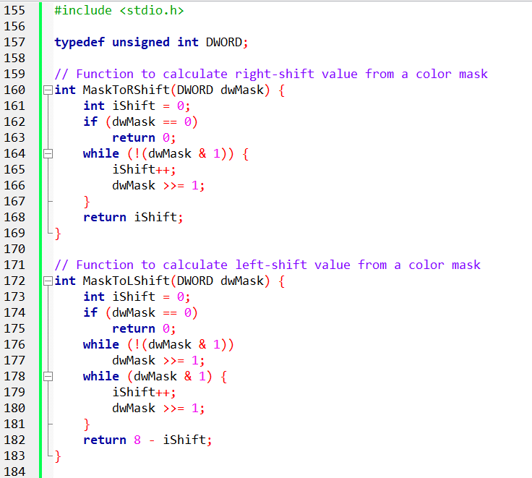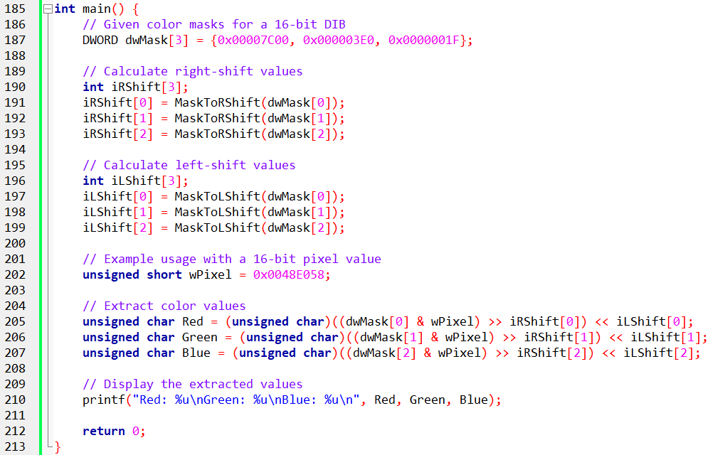

This part of the code is all about **pulling red, green, and blue out of a packed pixel**, even when the colors aren’t nicely lined up.

Think of it as:

*“Find where the color is hiding, move it into place, and resize it so it looks normal.”*

i. The Setup (Headers and Types)

**Including the Standard Library**

The code includes stdio.h so we can:

* Print values to the screen using printf
* See the final red, green, and blue numbers

Nothing special here — just basic C setup.

**The DWORD Type**



This is just a **shortcut name**.

DWORD means “a 32-bit number”

It’s perfect for pixel data because:

* Pixels are just numbers
* We don’t want negative values

So anytime you see DWORD, think:

*“This holds pixel or mask data.”*

ii. MaskToRShift — How Far Do We Slide Right?

**What This Function Does**

This function figures out:

*“How far do I need to slide this color to the right so it starts at bit 0?”*

In other words:

It finds **where the color begins** inside the pixel.

**If the Mask Is Zero**

If the mask is 0:

* There is no color
* No shifting is needed
* The function returns 0

Simple safety check.

**Finding the First 1 Bit**

If the mask isn’t zero:

* The function keeps shifting the mask to the right
* It counts how many shifts it takes until it sees the **first 1 bit**

That first 1 means:

*“This is where the color starts.”*

**What the Function Returns**

The function returns the number of shifts needed.

That number tells us:

*“Slide the pixel right this many times to line the color up.”*

iii. MaskToLShift — How Much Do We Scale It Up?

**Why Left Shifting Is Needed**

After right-shifting:

* The color is lined up
* But it may still be **too small** (like 5-bit or 6-bit color)

So, we need to **stretch it** to fill a full 8-bit range (0–255).

That’s what left shifting does.

**If the Mask Is Zero**

Same idea as before:

* No mask → no color → no shifting
* Return 0

**Step 1: Find Where the Color Starts**

The function:

* Shifts right until it finds the first 1 bit
* Counts how many shifts that took

This tells us:

*“Where does this color live?”*

**Step 2: Count How Big the Color Is**

It keeps shifting and counting until:

* All the 1 bits are gone

This tells us:

*“How many bits does this color actually use?”*

**Final Calculation**

At the end, the function returns:

8 - (number of bits used)

This tells us:

*“How much do I need to left-shift to make this an 8-bit color?”*

iv. Main Function — Pulling Colors Out of a Pixel

**Color Masks**



This array holds:

* Red mask
* Green mask
* Blue mask

Each mask is like a **stencil** that shows where that color lives inside a 16-bit pixel.

**Precomputed Shift Values**



Instead of figuring out shifts every time:

* We calculate them once
* Store them in arrays

This makes extraction:

* Faster
* Cleaner
* Easier to read

**Sample Pixel**



This is a **single 16-bit pixel** that contains:

* Red
* Green
* Blue  
  All packed together.

V. Extracting Each Color (Same Pattern Every Time)

For **each color** (red, green, blue), we do the same three steps:

**1. Mask It**



This:

* Keeps only the bits we care about
* Blocks everything else

**2. Right Shift It**



This:

* Slides the color to the right
* Lines it up neatly

**3. Left Shift It**



This:

* Scales the color up
* Makes it fit into an 8-bit range (0–255)

Now the color is ready to use.

VI. Final Result

The extracted colors are stored as:



Each one now represents:

* A normal color value
* From **0 to 255**

Finally, printf prints the values so we can see them.

VII. Big Picture Summary

* Pixels pack colors tightly to save space
* Masks tell us **where each color is**
* Right shifts move colors into position
* Left shifts scale them to full brightness
* The code works for **any 16-bit format**, not just one layout

THE ROLE OF COLOR MASKS (WHAT THEY REALLY DO)

In **Device-Independent Bitmaps (DIBs)**, color masks are basically **instructions** that explain how colors are packed inside a pixel.

A pixel is just a number.  
Color masks tell us:

“Which bits belong to red, which belong to green, and which belong to blue?”

This is especially important when the colors are **not stored in a fixed order**, like in BI_BITFIELDS.

Think of color masks as a **map or blueprint**. Without them, the pixel data would just look like random bits.

What BI_BITFIELDS Means (Why Masks Matter Here)

When the biCompression field is set to **BI_BITFIELDS**, the image is saying:

“Don’t assume a standard color layout. I’ll tell you exactly where each color is.”

Instead of using a fixed format (like BI_RGB), BI_BITFIELDS provides:

* One mask for **Red**
* One mask for **Green**
* One mask for **Blue**

Each mask is a 32-bit number that clearly marks:

* Where that color starts
* How many bits it uses

This gives a lot of flexibility:

* Colors can be packed tighter
* Bit sizes can vary
* The order of colors can change

But it also means:

You *must* use the masks to decode the pixel correctly.

How Colors Are Decoded Using Masks

I. Get the Masks from the Header

Before touching the pixel data, the program first reads:

* The **red mask**
* The **green mask**
* The **blue mask**

These come directly from the DIB header and describe the pixel layout. No guessing involved.

II. Figure Out How Much to Shift

The color bits are usually:

* Not aligned nicely
* Not already in the 0–255 range

So, we calculate two things for each color:

* **Right shift**:  
  How far to slide the bits so the color starts at bit 0
* **Left shift**:  
  How much to stretch the color so it fits into an 8-bit value

The helper functions (MaskToRShift and MaskToLShift) do this work automatically based on the mask.

III. Mask and Shift the Pixel

Now comes the actual extraction:

1. **Mask the pixel**  
   This keeps only the bits for one color and removes everything else.
2. **Right shift**  
   This moves the color into the correct position so it can be read.
3. **Left shift**  
   This scales the color up to a normal 8-bit range (0–255).

After these steps, the color value is clean, readable, and ready to use.

IV. Big Idea to Remember

* BI_BITFIELDS = **custom color layout**
* Color masks = **the rules for decoding it**
* Mask → shift right → shift left
* Result = standard red, green, and blue values

In short:

Color masks turn packed, confusing pixel data into real colors you can actually use.

Illustrative Example (16-bit DIB with BI_BITFIELDS):

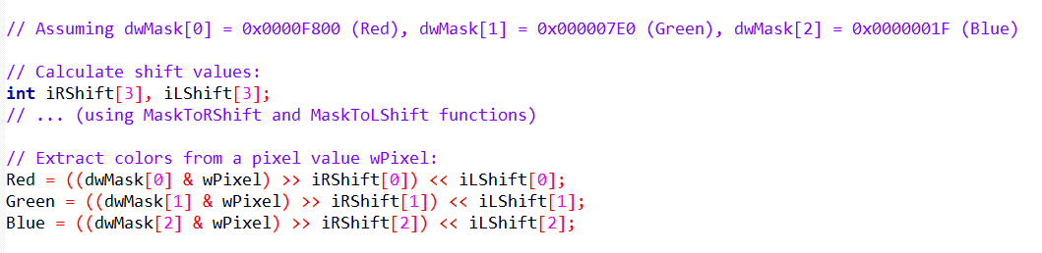

Key Things to Keep in Mind (32-bit BI_BITFIELDS)

When working with **32-bit DIBs** that use **BI_BITFIELDS**, the idea is very similar to the 16-bit case — but with **more room to work with**.

The steps are the same:

* Read the masks
* Use them to extract colors
* Shift and scale the values

What changes is **how big and flexible those masks can be**.

I. Bigger Masks, More Flexibility

In **32-bit BI_BITFIELDS**, color masks can be much larger than in 16-bit images.

* In 16-bit images, masks usually fit inside 0x0000FFFF
* In 32-bit images, masks can use **many more bits**

This means:

* More precision
* Smoother color transitions
* A wider range of colors if needed

In short:

*32-bit BI_BITFIELDS gives you more freedom in how colors are stored.*

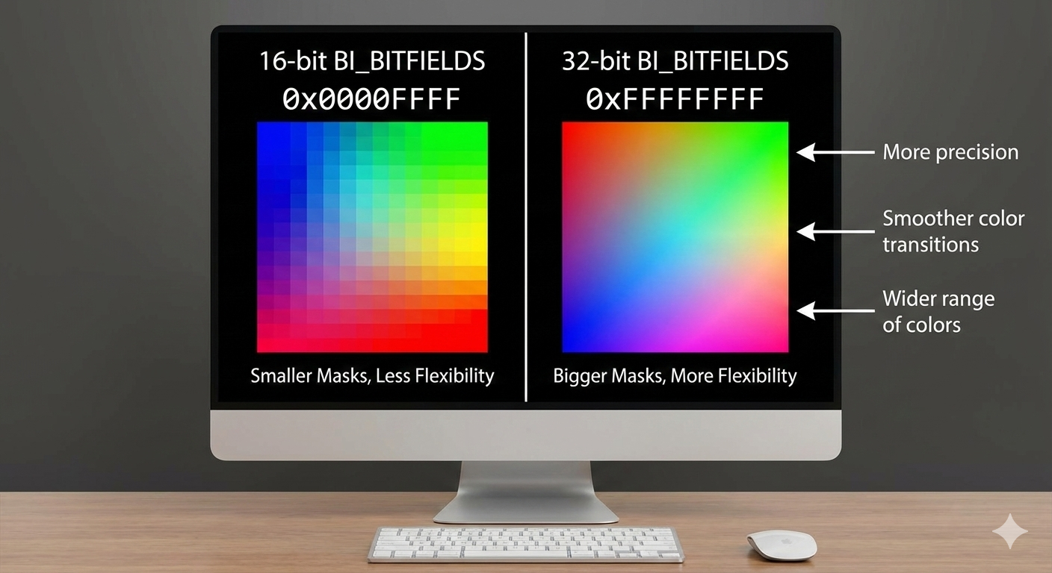

II. Color Values Can Go Beyond 255

With BI_BITFIELDS (both 16-bit and 32-bit):

* Color values are **not guaranteed** to be in the 0–255 range
* Some colors may use more or fewer bits

That’s why:

* Masking alone isn’t enough
* Shifting and scaling are required

Once extracted and adjusted, the values are converted back into the familiar **8-bit (0–255)** range that most graphics systems use.

**Windows 95 / 98 Compatibility (Old but Important)**

Older versions of Windows — especially **Windows 95 and Windows 98** — had **strict rules** about which mask values were allowed.

* Only specific mask patterns were supported
* Anything outside those rules could fail or display incorrectly

Because of this:

* Developers had to follow a predefined table of valid masks
* Custom layouts were limited

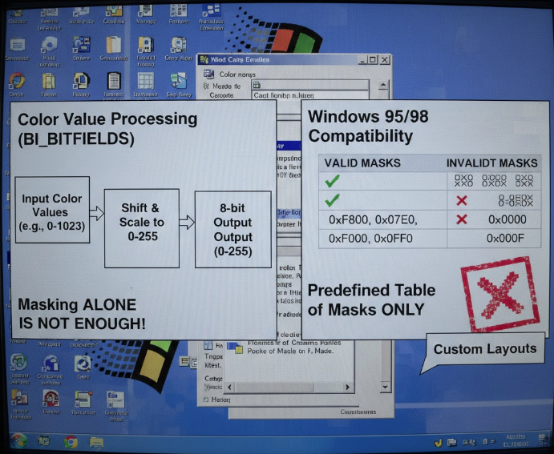

**Modern Windows Is Much More Relaxed**

On newer systems like **Windows 10 and Windows 11**:

* Mask restrictions are far less strict
* Developers can choose masks more freely
* Custom color layouts are easier to use

However:

If you care about backward compatibility with very old systems, you still need to respect those older rules.

The safest approach:

* Use modern masks when targeting modern Windows
* Follow Microsoft’s documented mask tables when legacy support matters

Why Use Custom Color Layouts?

BI_BITFIELDS isn’t just about flexibility — it’s about **optimization**.

Here are some real reasons to customize color masks.

I. Subsampling (Using Bits Where They Matter Most)

Not all colors matter equally to the human eye.

For example:

* Green is often more noticeable than blue
* You might give green more bits
* And give blue fewer bits

This can:

* Reduce file size
* Keep images looking good
* Use bits more efficiently

II. Matching Color Spaces

Custom masks can be designed to better match:

* sRGB
* Adobe RGB
* Or other color spaces

This helps with:

* Accurate color reproduction
* Color-managed workflows
* Professional graphics pipelines

III. Channel Priority

Sometimes one color channel is more important than others.

Examples:

* Medical imaging
* Scientific visualization
* Night vision or thermal imaging

By giving certain channels more bits:

* Important details are preserved
* Less important data can be compressed

Advanced Uses of Color Masks

Once you understand masking, you’re not limited to just reading pixels.

You can *manipulate* them.

I. Color Correction

Masks allow precise control over individual channels, enabling:

* White balance fixes
* Removing color casts
* Gamma adjustments

II. Color Effects

Custom masking makes it possible to:

* Apply effects to specific colors only
* Create sepia or grayscale effects
* Perform selective color grading

III. Image Segmentation

By checking color ranges:

* Objects can be isolated
* Backgrounds can be removed
* Regions can be processed independently

This is common in:

* Computer vision
* Object detection
* Image analysis

IV. Color Quantization

By limiting available color values:

* Bit depth can be reduced
* Posterization effects can be created
* Indexed or stylized images can be generated

Beyond the Basics

I. Custom Mask Design

BI_BITFIELDS allows developers to:

* Design their own color layouts
* Optimize for specific image types
* Balance quality, performance, and size

This can even reduce file size by:

* Using fewer bits where precision isn’t needed
* Packing colors efficiently

II. Why This Knowledge Matters

Understanding masks gives you:

* Full control over pixel data
* The ability to decode *any* BI_BITFIELDS image
* A foundation for advanced image processing

In short:

*Masks turn pixels from “mystery numbers” into something you fully control.*

BITMAPV4HEADER AND ADVANCED COLOR

The standard BITMAPINFOHEADER was great for the 1980s, but it had a flaw: it assumed "Red" on my monitor looked exactly like "Red" on your printer. (Spoiler: It never does.) Windows 95 introduced BITMAPV4HEADER to fix this by adding **Color Management**.

I. The Custom Masks (BI_BITFIELDS)

In the previous section, we saw the standard "5-5-5" layout (5 bits for Red, Green, Blue). But what if you want to use that wasted bit?

Developers realized the human eye is most sensitive to **Green**. So, they created the **"5-6-5"** format, giving Green an extra bit of detail.

To use this, you set *biCompression* to BI_BITFIELDS and define custom masks in the V4 Header.

* **16-Bit (5-5-5):** The classic. Wastes 1 bit. 0x7C00 (Red), 0x03E0 (Green), 0x001F (Blue).
* **16-Bit (5-6-5):** The "Green" optimization. Uses all 16 bits. 0xF800 (Red), 0x07E0 (Green), 0x001F (Blue).
* **32-Bit (8-8-8):** Pure luxury. 8 bits per color. 0x00FF0000 (Red), 0x0000FF00 (Green), 0x000000FF (Blue).

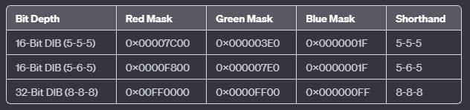

I. The Color Management Problem (ICM)

**The Problem:** RGB is "Device Dependent." If you tell a cheap monitor "Show Red 255," it glows a weak orange-red. If you tell a high-end laser projector "Show Red 255," it burns your retinas with deep crimson. The numbers are the same, but the *color* is different.

**The Solution: CIE XYZ (The Universal Passport)** The V4 header includes a "Color Space" field (bV4CSType). It translates your RGB values into **CIE XYZ**—a scientific, mathematical map of all visible light created in 1931.

* **RGB:** "Go 5 blocks east." (Depends on how big a 'block' is in your city).
* **CIE XYZ:** "Go to GPS coordinate 40.7128° N." (Exact same spot everywhere).

III. The "Gamma" Knobs

The V4 header also adds bV4GammaRed, bV4GammaGreen, and bV4GammaBlue. These are not just "Brightness" sliders. They are **Linearity Correction Curves**.

* **Gamma 1.0:** If you double the pixel number, the screen emits double the light (Linear).
* **Gamma 2.2 (Standard):** Screens are dark by nature. You need to boost the mid-tones significantly to make them look "normal" to the human eye. The V4 header lets the image file carry its own instructions on how to perform this boosting.

IV. Explain Like I'm a Teenager: The Instagram Filter

Think of BITMAPV4HEADER like posting a photo to Instagram with a **Filter** baked in.

* **Old Bitmap:** You send a raw photo. It looks great on your phone, but dark and green on your friend's laptop.
* **V4 Bitmap:** You attach a note:   
  *"This photo was taken on an iPhone with 'Vivid' settings."*

Your friend's laptop reads the note (ICM Profile) and automatically adjusts the colors so they look exactly like they did on your phone.

Structure Breakdown:

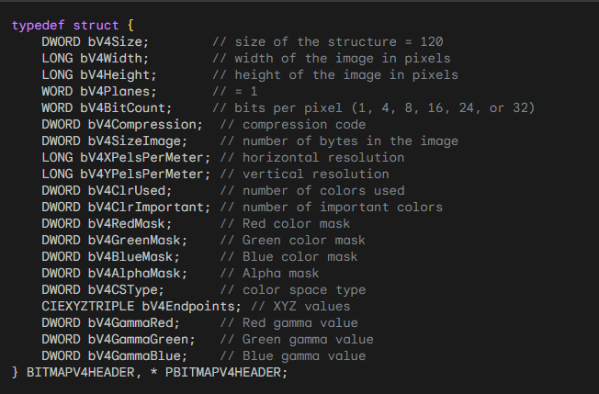

Beyond the Basics — Color Management (ICM) Made Simple

Up to now, we’ve talked about **where colors are stored** and **how to extract them**.  
This part explains how Windows makes sure those colors **look right on different screens and devices**.

That’s where **ICM (Image Color Management)** comes in.

I. ICM in Real Use (What Those Extra Header Fields Do)

In a **BITMAPV4HEADER**, the last four fields are all about color management.

Together, they tell Windows:

* What the colors *really mean*
* How they should be displayed
* How to adjust them for different devices

You can think of these fields as:

*A set of instructions that helps Windows translate colors correctly for each screen, printer, or device.*

Without ICM:

* Colors might look fine on one monitor
* But too dark, too bright, or slightly off on another

II. The XYZ Color Space (A Neutral Meeting Place)

The **XYZ color space** is a device-independent color system.

That means:

* Colors aren’t tied to any specific monitor or printer
* They’re defined based on **human vision**, not hardware

Think of XYZ as:

A neutral reference point where all devices agree on what a color actually is.

When a color is defined in XYZ:

* Windows can accurately convert it
* Any device can display it as closely as possible

III. Gamma Values (How Brightness Is Balanced)

Gamma controls how brightness and contrast behave. Different devices:

* Respond to brightness differently
* Display dark and light colors in their own way

Gamma values tell Windows:

*“Here’s how this device handles brightness — adjust the colors accordingly.”*

The result:

* Shadows don’t get crushed
* Highlights don’t get blown out
* Colors feel natural instead of harsh

IV. Why This Matters

Without ICM:

* The same image can look different everywhere
* Designers, photographers, and users lose consistency

With ICM:

* Colors stay visually consistent
* Images look closer to how they were intended
* Devices speak the same “color language”

V. Going Deeper (If You Want To)

ICM goes far beyond simple color correction.

It enables:

* Accurate color workflows.
* Professional image and print matching.
* Reliable color reproduction across devices.

Most of the time, this all happens **quietly in the background** — but understanding it explains *why* modern systems can keep colors looking right almost everywhere.

VI. Big Takeaway

* Masks and bitfields define **where colors live**
* ICM defines **what those colors mean**
* XYZ provides a shared color reference
* Gamma fine-tunes how colors appear

**In short:** *ICM makes sure colors stay honest, no matter where they’re displayed.*

Understanding the CIE XYZ Color Equations

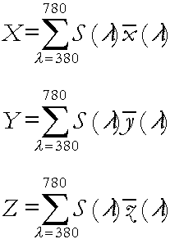

The CIE XYZ equations are used to describe a color in a **device-independent way** — meaning the color is defined by **human vision**, not by a screen, printer, or camera.

Each color is described using **three values**:

* **X**
* **Y**
* **Z**

Together, these three numbers fully describe how a color is perceived by the human eye.

I. The Big Idea Behind the Equations

Light is made up of many **wavelengths** (like a rainbow).

To figure out a color’s XYZ values, the equations:

1. Look at **how much of each wavelength** is present
2. Weigh each wavelength by **how sensitive human vision is to it**
3. Add everything together

That’s it.

II. What the Symbols Mean (Once, Clearly)

* **Σ (Sigma)**  
  Means “add everything up.”
* **λ (Lambda)**  
  Represents wavelength, covering the visible range (about 380–780 nm).
* **S(λ)**  
  Tells us how strong each wavelength is in the light source.
* **x̄(λ), ȳ(λ), z̄(λ)**  
  These are **human vision filters**.  
  Each one models how sensitive our eyes are to different wavelengths.
* **dλ**  
  A very small slice of the spectrum — like sampling the rainbow one tiny step at a time.

What Each Equation Does

i) X Equation — Color Balance

The **X value** measures how strongly the light matches one part of human color perception.

It’s influenced by:

* Red and green wavelengths
* Overall color balance

ii) Y Equation — Brightness (The Important One)

The **Y value** is special.

It closely matches:

* **How bright the color looks to humans**

That’s why Y is often used for:

* Luminance
* Grayscale conversions
* Brightness calculations

In simple terms: Y answers the question: *“How bright does this color look?”*

iii) Z Equation — Blue Influence

The **Z value** captures another dimension of vision, with a stronger link to:

* Blue wavelengths
* Blue–yellow color differences

Z doesn’t map directly to brightness like Y does, but it completes the color description.

Why We Need All Three (X, Y, Z)

Each equation looks similar, but:

* They use **different human vision filters**
* Each captures a **different aspect of perception**

Together:

X, Y, and Z form a complete, three-dimensional description of color.

This makes XYZ:

* Accurate
* Consistent
* Independent of hardware

A Simple Analogy

Think of:

* **RGB** as ingredients (red, green, blue)
* **XYZ** as a scientific measurement of how the finished color actually looks
* **ICM** as the system that translates those measurements so every device shows the color correctly

Or:

XYZ tells us *what the color really is*, and ICM makes sure devices respect that.

Why This Matters

Because of these equations:

* The same color can look consistent across screens and printers
* Colors can be converted reliably between color spaces
* Professional color workflows are possible

Without XYZ:

* Every device would “guess” what a color means
* Color accuracy would fall apart

Final Takeaway

* The equations add up light across all wavelengths
* Human vision determines the weighting
* X, Y, and Z together fully define a color
* The result is a **true, device-independent color description**

Clean, scientific, and reliable — even if the math looks intimidating at first.

CIEXYZTRIPLE AND CIEXYZ: BASIC COLOR-BUILDING BLOCKS FOR DEVICE-INDEPENDENT COLOR

**CIEXYZTRIPLE**  
This is a group of three colors: red, green, and blue.  
Each color is described using the CIE XYZ color system.  
It helps computers show colors in a way that matches how humans see them.

**CIEXYZ**  
This describes one color using three numbers (X, Y, Z).  
These numbers tell exactly where the color is in the CIE XYZ system.

**FXPT2DOT30**  
This is just a way to store numbers accurately while using less space.

BITMAPV4HEADER: Color Management

**bV4CSType**  
This tells what color system the image uses.  
When it is set to **LCS_CALIBRATED_RGB**, it means colors should look correct on any device.

**bV4Endpoints**  
These are the XYZ values for red, green, and blue.  
They help make sure colors look the same on different screens.

Gamma Correction: Making Colors Look Right

**Gamma (γ)**  
Gamma fixes the problem that screens do not show brightness in a straight, simple way.  
A number sent by the computer does not always match how bright the screen looks.

**Why this happens**  
Older screens (like CRTs) and modern displays naturally change brightness in a curved way, not a straight line.

**Formula**  
The formula explains how voltage turns into brightness on the screen.

**Cameras and gamma**  
Video cameras often adjust gamma (usually around 0.45) so images look normal and consistent on screens.

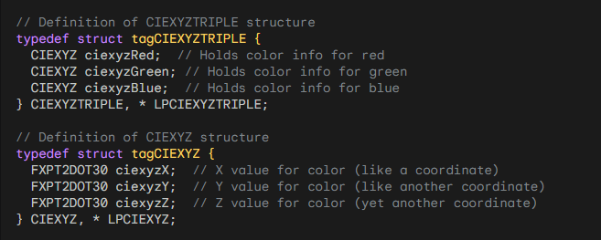

***Explanation of Fields and Values:***

* **Big X, Big Y, and Big Z** describe how humans see color.  
  They are based on how our eyes react to light from violet (380 nm) to red (780 nm).
* **Y** is special because it shows how bright the color is overall.
* In **BITMAPV5HEADER**, setting **bV4CSType** to LCS_CALIBRATED_RGB (0) means the image uses a standard color system that works the same on all devices.
* **CIEXYZTRIPLE** stores three colors: red, green, and blue.  
  Each one is described using X, Y, and Z values.
* **FXPT2DOT30** is just a precise way to store numbers using fixed-point math.
* **bV4Endpoints** gives XYZ values for pure red, green, and blue  
  → (255,0,0), (0,255,0), and (0,0,255).  
  These values define what RGB really means, no matter the device.
* The last three fields in **BITMAPV4HEADER** control **gamma**.
* **Gamma correction** fixes the problem that screens don’t show brightness evenly.
* The formula **I = (V + e)^γ** explains how brightness is calculated.
* Cameras usually use a gamma of **0.45**, which matches screens that have a gamma around **2.2**.
* This makes images look natural and consistent on different displays.

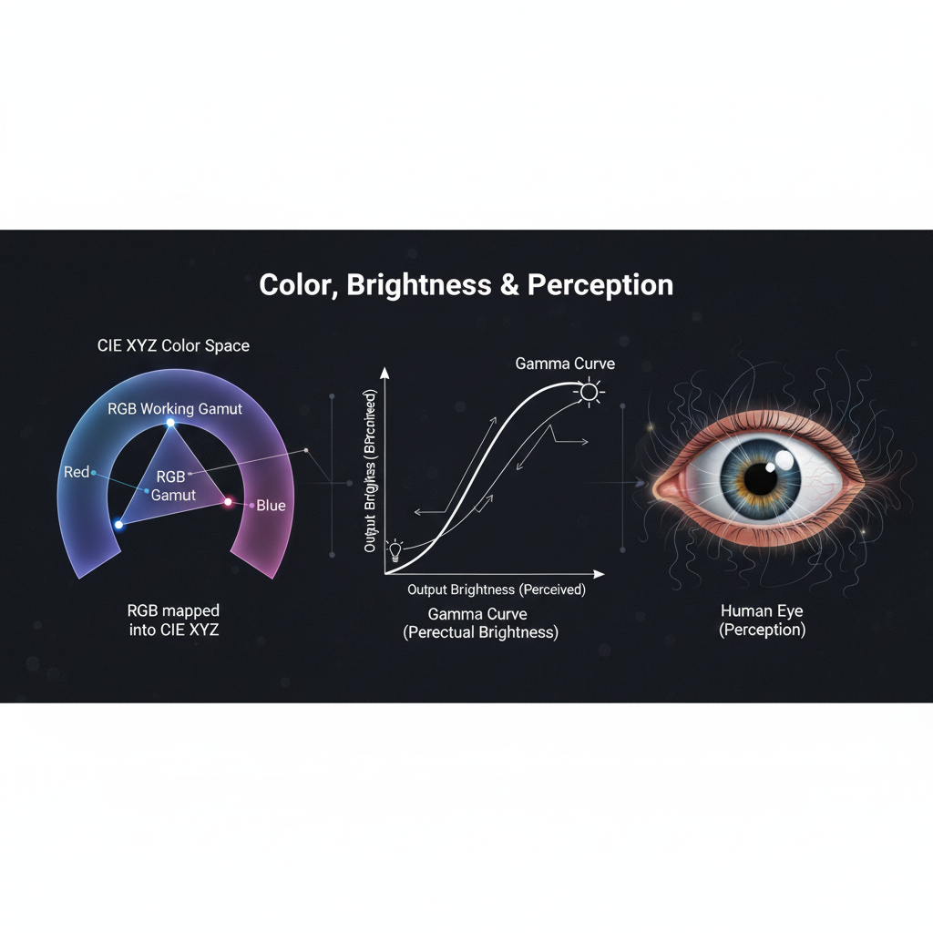

Summary of what we’ve talked about:

* **CIE XYZ**: A standard color system that works the same on any device.
* **BITMAPV4HEADER**: Stores color space info in image files for consistent colors.
* **bV4Endpoints**: Shows the true meaning of red, green, and blue in XYZ values.
* **Gamma correction**: Fixes uneven brightness from displays and cameras, making colors look natural.
* Video cameras usually use gamma correction to match screen behavior and ensure images look correct.

NONLINEAR RESPONSE AND HUMAN PERCEPTION

When we talk about monitors and images, there’s a big idea to understand:

**Humans don’t see light in a straight line.**

A monitor might double the voltage to make a pixel “twice as bright,” but our eyes **won’t see it as exactly twice as bright**.

Instead, our perception of brightness grows more slowly at higher light levels. This is called a **nonlinear response**, and monitors actually take advantage of it.

CIE Luminance and Lightness (Y and L*)

To describe brightness in a way that matches human vision, the **CIE** defines:

1. **Y** – The actual linear luminance of a color (how much light energy is there)
2. **L**\* – The perceived lightness, which approximates how humans see brightness

The formula for L* looks fancy, but here’s the **idea**:

**L* = (Y / Yn) (1/3) * 100**

**Yn** is the luminance of pure white (the brightest point the system can show)

L* ranges from **0 to 100**, where:

* 0 = black
* 100 = white

Each whole number increment in L* roughly represents the **smallest change in brightness your eyes can notice**

Think of L* as a **human-friendly brightness scale**.

Why L* Is Better Than Linear Luminance

Imagine storing pixel brightness directly as **Y values**.

* At very low brightness, tiny differences in Y are noticeable
* At very high brightness, the same differences in Y might not be noticed at all

This wastes **data precision**.

Instead, we store brightness using \**perceptual lightness (L*)**:

I. Convert pixel value to a normalized intensity:

**Intensity = (P / 255) g**

* **P** = pixel value (0–255)
* **g** = monitor gamma
* Assume black = 0

II. Then take the cube root (or apply the L* formula)

* This matches **how humans actually perceive brightness**
* It ensures that changes in pixel values correspond to changes we can see

In short: L* makes every step in pixel brightness **meaningful to our eyes**.

Gamma Correction in BITMAPV4HEADER

The last three fields of **BITMAPV4HEADER** store **gamma values**.  
Gamma is basically a number that tells the program:

*"How do pixel values relate to perceived brightness?"*

Stored as **16-bit integer + 16-bit fraction**

Example:

* 0x10000 = 1.0 (linear)
* 0x23333 ≈ 2.2 (typical for real-world images)

If the image came from a real photo:

* Gamma ≈ 2.2 (matches how cameras and monitors work)

If the image is generated by a program:

* Linear luminance is converted to **perceptual L**\* using a power function
* The inverse of that exponent gives the gamma value stored in the DIB

This ensures:

* The monitor shows brightness in a **way our eyes expect**
* The image looks **natural and smooth**, not too dark or too bright

Key Takeaways

1. **Human eyes are nonlinear** — we notice small changes in dark areas more than bright areas.
2. **L**\* maps linear light to perceptual brightness, making pixel values visually meaningful.
3. **Gamma correction** ensures monitors display images according to how we perceive light.
4. Using L* and gamma makes images **look natural** on any device.

Analogy

Think of it like a **volume knob**:

* A linear knob might go from 0–100, but your ears don’t hear a linear increase in volume.
* Gamma correction is like **reshaping the knob** so that each step feels like an equal increase in loudness.
* L* is your **perceptually balanced scale for brightness**, just like adjusting volume so music feels smooth at every level.

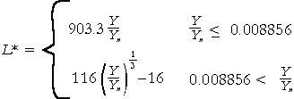

Coding Pixel Brightness Using Perceptual Lightness

When we deal with images and monitors, it’s important to remember:

**Humans don’t see brightness in a straight line.**

A monitor might double the light output, but our eyes **won’t see it as twice as bright**. To handle this, we use **perceptual lightness (L*)** instead of raw linear luminance.

I. Why Perceptual Lightness?

* Using **linear light values** wastes bits in bright areas where the eye can’t notice small differences.
* **L\*** matches human perception, so each step in pixel value corresponds to a visible change in brightness.
* This also **reduces noise in analog circuitry** and keeps the number of bits needed reasonable.

II. Step-by-Step Process

**🥩 Start with the Pixel Value** - Each pixel has a value **P** between 0 (black) and 255 (white).

**🥩 Normalize to a Voltage/Intensity -** Convert P to a number between **0.0 and 1.0**:



This is like setting a dimmer on a lamp from 0 (off) to 1 (full brightness). Assuming the monitor’s black level is 0, this voltage directly corresponds to the **intensity of light emitted** by the pixel.

**🥩 Account for Human Perception (Gamma / Cube Root)**

* Humans perceive brightness **nonlinearly**. To make the pixel values feel right, we transform intensity to **perceptual lightness (L*)**.
* A good approximation uses the **cube root of intensity**:

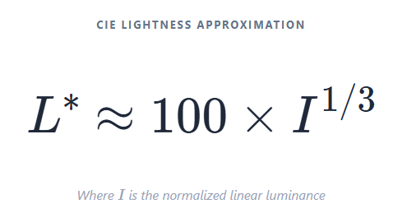

OR equivalently, using P directly:

L* ranges from **0 (black) to 100 (white)**, with each step roughly representing the smallest change in light the human eye can notice.

In simpler terms: the cube root “reshapes” brightness so that **dark areas get more precision**, and bright areas don’t waste bits.

III. Exponent and Gamma

* The exponent used in the cube root formula is typically around **0.85**, not exactly 1.
* If it were 1, L* would match the linear pixel values exactly, but our eyes don’t see linearly, so the cube root gives a **much closer match to human perception**.
* This exponent is closely related to **gamma correction**, which adjusts pixel values for how humans perceive brightness.

IV. How Gamma Works in BITMAPV4HEADER

The last three fields in **BITMAPV4HEADER** let programs **store the gamma value** associated with the pixel data.

Gamma is stored as **16-bit integer + 16-bit fractional** values.

* Example: 0x10000 = gamma 1.0 (linear)
* Example: 0x23333 ≈ gamma 2.2 (common for real photos)

If a DIB is captured from a camera:

* The hardware usually sets gamma (≈ 2.2)

If a DIB is generated by a program:

* Linear luminance is converted to **L**\* using a power function
* The inverse of the exponent is then stored as the gamma in the DIB

This ensures that the **image appears correct on a monitor**, matching human perception no matter the device.

V. Big Picture

1. Pixel value P → normalized intensity (0–1)
2. Intensity → cube root → perceptual lightness L*
3. Gamma correction → ensures monitors display it correctly
4. Result → every step in brightness is meaningful to human eyes

VI. Analogy

Think of it like **a dimmer for a lamp**:

* Linear dimmer: halfway doesn’t feel half as bright
* Perceptual dimmer (L*): halfway really **feels halfway**, matching human perception
* Gamma = the math behind adjusting the dimmer so the room looks natural

VII. Some additions before we move on

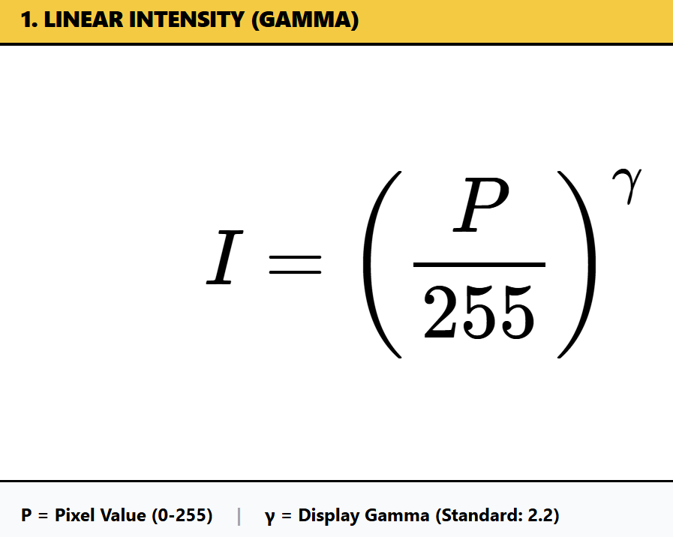

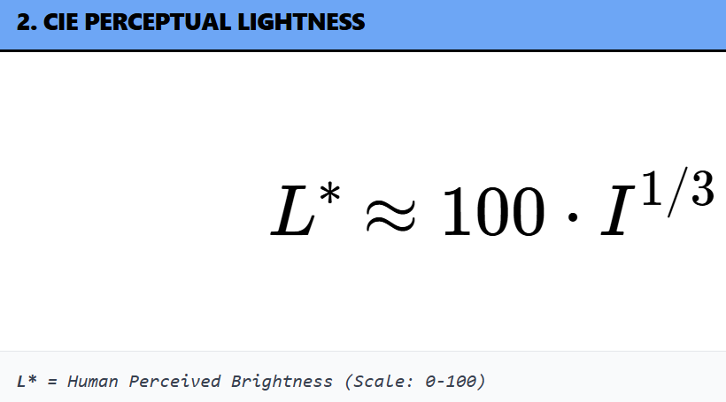

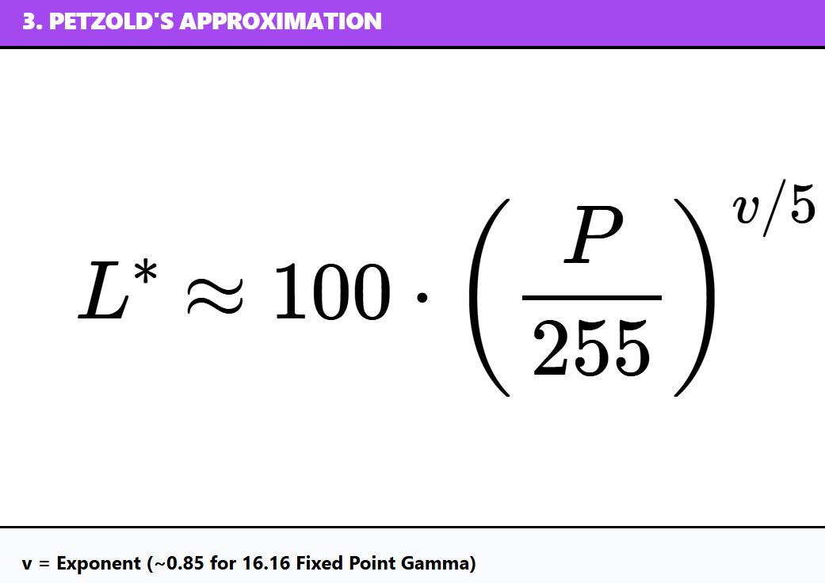

*Let’s explain the formulas…*

L Lightness Formula (CIE Lab)*

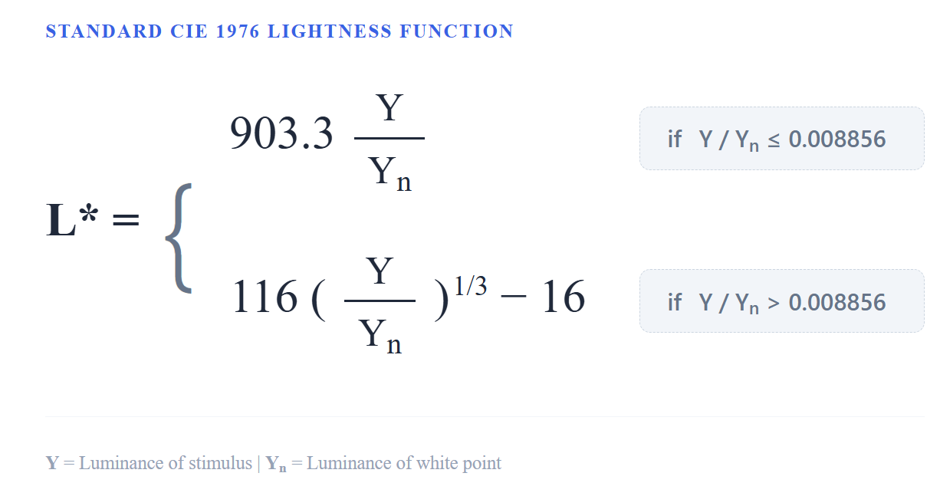

Here’s what each part means in simple terms:

* **L\*** – The **CIE Lightness**, our final “human-perceived” lightness value. It goes from 0 (black) to 100 (white).
* **Y** – The **linear luminance**, meaning the actual light intensity of a color.
* **Yn** – The **reference white level**, used to normalize values so that the same formula works under different lighting conditions.
* **(Y / Yn)** – Dividing the color’s brightness by the white reference gives a proportion of maximum brightness.
* **( )^(1/3)** – The **cube root**, which converts linear light intensity into a value that better matches how we perceive brightness.
* **100** – Just a scaling factor to make the final L* range from 0 to 100, which is easy to work with.

I. Key Points to Remember

1. **Reflects Human Perception:** The cube root makes L* nonlinear, which aligns with how our eyes perceive changes in light.
2. **Normalized Lightness:** By dividing by the reference white **Yn**, we can compare lightness consistently across different scenes or images.
3. **Practical Range:** L* values are scaled from 0–100, giving a straightforward way to measure “how light or dark” a color looks.
4. **Gamma in BITMAPV4HEADER:** Images often store gamma information in this header so that software knows how to interpret the pixel values correctly, ensuring the image **looks right on different monitors**.

II. Analogy 💡   
Think of L* like a **volume knob for brightness** that’s tuned to human eyes. If linear luminance (Y) were a raw electrical signal, L* adjusts it so that each step feels like the same perceptual difference in light to our vision.

Components of the Pixel Intensity Formula

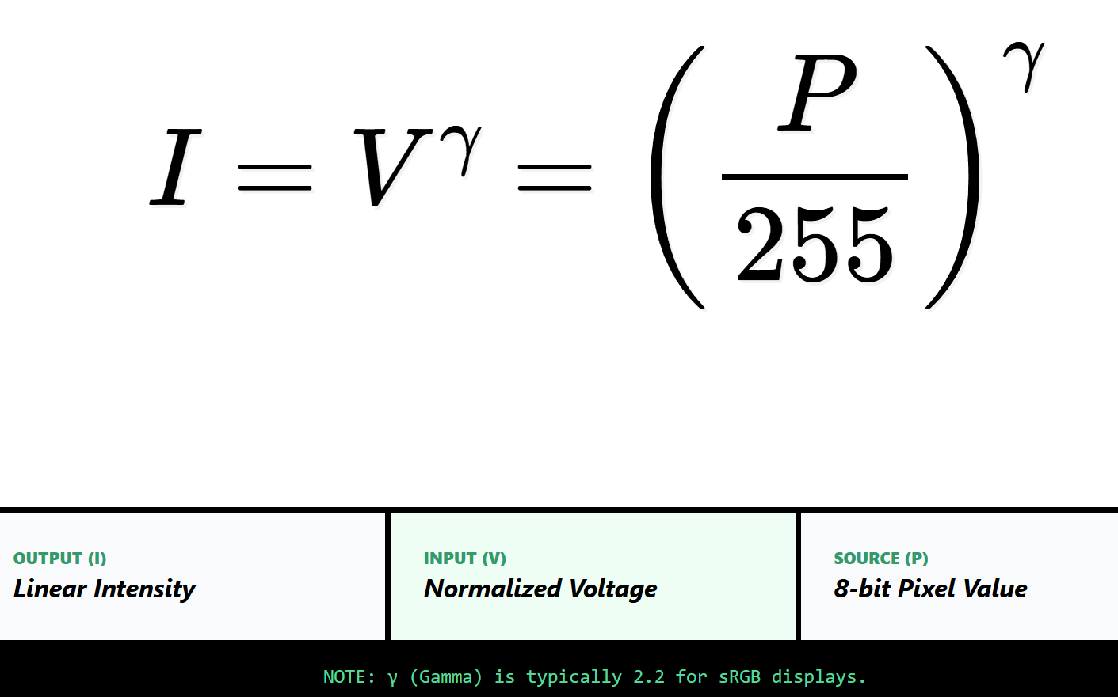

* **I (Intensity):** How bright the pixel actually looks on the screen.
* **V (Voltage):** The electrical signal the monitor uses to display that brightness.
* **P (Pixel Value):** The number stored in the image for that pixel, from **0 (black) to 255 (white)**.
* **255:** This is just a normalization factor, turning the pixel value into a number between 0 and 1.
* **Exponent (power):** This controls the nonlinear relationship between the pixel value and the voltage or intensity.

I. What the Exponent Usually Is

* **Gamma (γ):** Most of the time, this exponent is **gamma**, which is usually around **2.2**. It accounts for the fact that monitors (especially old CRTs) don’t respond linearly to voltage. This means a small change in the pixel value doesn’t make a small change in brightness—it’s more noticeable.
* **Other Exponents:** Depending on the situation, other exponents might be used. Some image processing algorithms tweak this exponent to achieve special effects or correct for specific hardware.

II. Understanding the Formula

The formula turns a file's numbers into the electrical signals that light up your screen.

It uses a specific 'curve' (the exponent) because humans don't see brightness in a straight line—we’re more sensitive to changes in shadows than in bright light.

*L* (Lightness) Formula

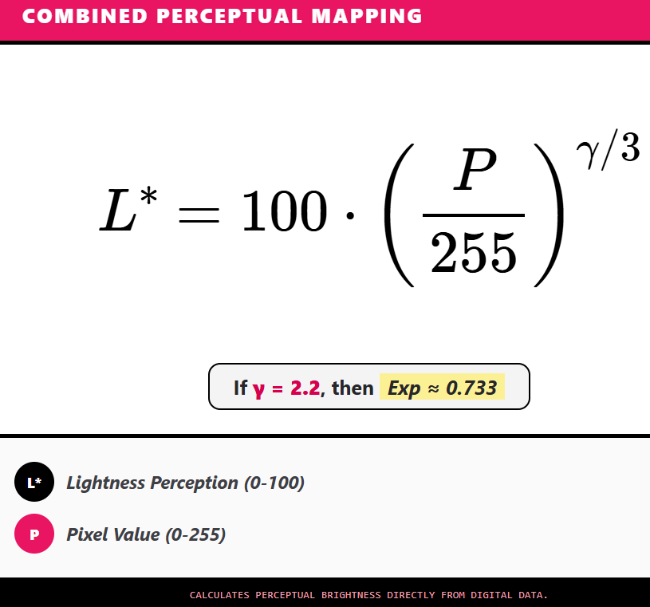

I. The Components

* **L\*** (Lightness): This is the final result. It’s a score from 0 (Pitch Black) to 100 (Blinding White).
* **P** (Pixel Value): This is the raw number from your image file (0 to 255).
* **255**: We divide by this to turn the pixel number into a percentage (between 0 and 1).
* **Exponent (EXP)**: This is the "secret sauce." It’s a math trick that curves the brightness so it looks natural to humans.

II. The "Secret Sauce" (The Exponent)

The notes give two options for the math trick:

* **The Cube Root (1/3)**: A simple, old-school way to adjust brightness. Think of it like a "basic" filter.
* **The Gamma Version (gamma/3)**: A more precise method. It accounts for how your specific monitor (like your phone or laptop screen) handles light. Most screens use a gamma of 2.2.

III. The "Why" Behind the 100

* The final L* value usually ends up between 0 and 100. Think of it like a Lightness Percentage.
* If L* = 50, your brain thinks, "That's exactly middle-gray."
* If the computer just used raw numbers, a "50" might look too dark. This formula boosts the middle values so they look correct.

IV. Summary in one sentence  
This formula takes a raw pixel number (0–255), turns it into a percentage, and then applies a math "curve" so the brightness you see matches what the computer intended.

BITMAPV5HEADER Overview and Color Management

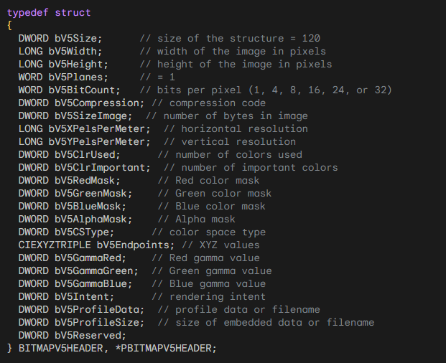

I. Purpose:  
BITMAPV5HEADER builds on previous DIB headers to give better control over colors and color management. It’s 124 bytes long and adds fields for color space, gamma, and ICC profiles.

II. Key Fields:

* bV5CSType: Specifies the color space (sRGB, calibrated RGB, Windows default, or embedded/linked ICC profile).
* bV5Endpoints: Holds XYZ values that define the color space endpoints.
* bV5GammaRed, bV5GammaGreen, bV5GammaBlue: Gamma values for each channel.
* bV5ProfileData & bV5ProfileSize: Handle ICC profile information for device-independent color.

III. Why It Matters:

* BITMAPV5HEADER lets programs store images with precise, device-independent colors.
* ICC profiles ensure colors stay consistent across monitors, printers, and other devices.

Working with DIB Files in Code

A typical Windows program for inspecting DIB headers (like DIBHEADS.c) works as follows:

1. **Open the File:** The program reads the DIB file into memory.
2. **Check the File Size:** Ensures the file is manageable.
3. **Read Headers:** Extracts the BITMAPFILEHEADER and one of the information headers (CORE, INFO, V4, or V5).
4. **Display Information:**
   * Shows width, height, bit depth, compression, color masks, gamma, and profile info.
   * For BITMAPV5HEADER, includes advanced color management fields.
5. **User Interface:**
   * Simple Windows interface with “File → Open” menu.
   * Opens a file dialog, lets the user select a DIB, and displays header info in a text field.
6. **Error Handling:** Any issues (file missing, read error) are reported gracefully.
7. **Optional Rendering:** To actually display or print the image, Windows functions like SetDIBitsToDevice or StretchDIBits can be used.

DIB Structure at a Glance

1. **BITMAPFILEHEADER:** Basic file info (type, size, pixel offset).
2. **BITMAPINFOHEADER / BITMAPV5HEADER:** Image properties (width, height, bit depth, compression, color masks, gamma, color space).
3. **Color Table (optional):** Only for indexed-color images, mapping pixel values to RGB colors.
4. **Pixel Data:** Actual pixel values, organized according to bit depth and compression.

💡 **Tip:** Most of the technical details (field names, offsets) can be read directly from the code or documentation. The important takeaway is: **BITMAPV5HEADER + ICC profiles = accurate, device-independent color handling.**

DISPLAYING DIBS AND PACKED DIBS

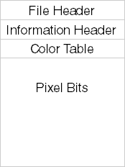

When you display a DIB (Device-Independent Bitmap), you need a few key pieces of information:

* Image width and height
* Color depth (bits per pixel)
* Compression type
* Color masks (if used)
* The actual pixel data

These details let the system correctly interpret and render the image on the screen or other output devices.

I. Packed DIBs: Storing a DIB in Memory

A **packed DIB** is when the entire DIB (except the file header) is stored as a single, continuous block of memory.

The memory starts at the **information header**, followed immediately by the **color table** (if there is one) and then the **pixel data**.

Think of it like this: everything needed to display or manipulate the image is stored in one neat package. This makes it easy to:

* Access image properties like width, height, color depth, or compression
* Loop through pixel data to read or modify colors
* Apply image processing operations like filters or transformations

In code, a packed DIB is usually referenced by a single pointer, such as pPackedDib. By using this pointer, you can navigate through all the sections in memory without worrying about separate blocks.

II. Why Packed DIBs Are Useful

Packed DIBs are common in situations like:

* Copying images through the clipboard
* Creating brushes from a DIB for drawing

They have several advantages:

1. **Compact Storage:** Keeps the image data together, reducing memory overhead.
2. **Easy File Handling:** Matches the structure used in BMP files, so it’s easy to save or load directly.
3. **Simple Structure:** With everything in one block, accessing and manipulating pixel data is straightforward.

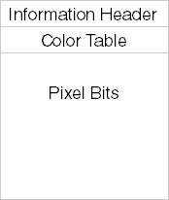

A packed DIB is basically a “ready-to-use” DIB in memory. It combines the information header, optional color table, and pixel data into one continuous block, making it easy to display, manipulate, or store.

III. Creating a Brush from a Packed DIB:

Creating a brush from a packed DIB involves using the CreateDIBPatternBrushPt function. Below is an example in C:



Here, pPackedDib is a pointer to the packed DIB data. The DIB_RGB_COLORS flag indicates that the color table should be in RGB format.

IV. Limitations and Considerations

Even though packed DIBs are widely used, there are some things to keep in mind:

* **Different DIB versions**: Old OS/2 formats and newer versions store information differently. This means your code might need extra checks to read the right data.
* **Accessing pixel data**: Some fields, like pixel width, aren’t always in the same place. Older formats might need special handling.
* **Compatibility matters**: Always check the DIB format before using its fields. Skipping this can lead to errors or crashes.

**Tip:** Think of it like reading books from different editions — the chapters (fields) might be in different orders, so you need to check the edition before jumping in.

ACCESSING PIXEL WIDTH IN A PACKED DIB

Getting information from a packed DIB isn’t always as simple as it looks because DIBs can come in different formats. One common task is retrieving the **pixel width** of the image.

A straightforward approach might look like this:



…but this only works for standard Windows DIB formats. Some DIBs, especially **OS/2-compatible ones**, use a slightly different structure, so a simple cast may not work correctly.

To handle both cases, you need a **conditional check**:



Here’s what’s happening:

* **bcSize check:** If the size of the header matches BITMAPCOREHEADER, we know it’s an OS/2-compatible DIB.
* **OS/2 DIB:** Use bcWidth to get the width in pixels.
* **Windows DIB:** Use biWidth from the BITMAPINFOHEADER structure.

This ensures your code works no matter what kind of DIB you’re dealing with. It’s a small but crucial step because accessing the wrong field can lead to incorrect image processing or crashes.

Fun Exercise: Accessing a Specific Pixel

Suppose you want the pixel at coordinate **(5, 27)**. To do this properly, you need:

* Image width and height
* Bits per pixel (bit count)
* Row byte length (how many bytes each row takes)
* Color table entries (for indexed images)
* Any color masks (for BI_BITFIELDS formats)
* Compression method (if used)

Directly calculating pixel addresses can get messy, especially for image processing tasks. That’s why **C++ classes for DIBs** are handy—they allow **fast random access** to pixel data without writing complex pointer arithmetic.

For now, in plain C, you’ll do manual calculations, but we’ll cover efficient methods in the next chapter.

SETDIBITSTODEVICE AND STRETCHDIBITS FUNCTIONS

To use these functions, you need:

A pointer to the **BITMAPINFO** structure of the DIB. This includes:

* **BITMAPINFOHEADER** (image metadata)
* The **color table**

A pointer to the **pixel bits**.

Getting the pixel pointer is usually easy if you have the **bfOffBits** field from the BITMAPFILEHEADER, which tells you where the pixel data starts.

**Important note:** If you get a packed DIB from the clipboard, it might **not** include a BITMAPFILEHEADER. This makes it trickier to find the pixel data.

**Tip:** Think of bfOffBits like a “map” telling you where the actual pixels live in the file. Without it, you have to search a bit more carefully.

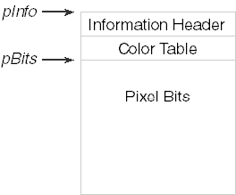

I. Why Two Pointers Are Needed

The **SetDIBitsToDevice** and **StretchDIBits** functions need **two separate pointers** to a DIB:

1. One pointer for the **header** (BITMAPINFO + color table)
2. One pointer for the **pixel data**

Why? Because the header and pixel data **don’t have to be stored in one continuous block of memory**.

* Sometimes they are in **two separate memory blocks**, and these functions can handle that.

**Tip:** Think of it like a book where the table of contents and the pages are stored in different locations—you need a pointer to both to read the full story.

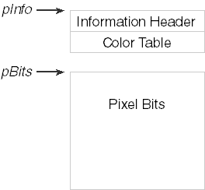

When using **SetDIBitsToDevice** or **StretchDIBits**, you work with **two separate pointers**:

**lpBits** – points to the **pixel data**

* This is the block of memory that holds the actual pixel colors.
* Pixel data can be in different formats, like **uncompressed RGB** or **compressed formats**.

**lpBitmapInfo** – points to the **header section**

* This memory block contains the DIB’s **header information**, like the **BITMAPINFO / BITMAPINFOHEADER** structure.
* It also includes the **color table** if the image uses one.

By giving these two pointers to the functions, you can:

* Specify **exactly where the header and pixel data live**, independently.
* Work with DIBs stored in **non-contiguous memory blocks**, which gives more flexibility in memory management.

**Tip:** Think of it like a recipe book where the ingredients (header info) are in one folder, and the instructions (pixel data) are in another—you need both to make the dish.

II. Example Call (conceptual):

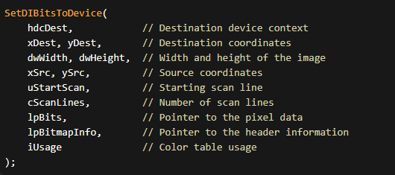

In functions like **SetDIBitsToDevice** and **StretchDIBits**, you usually pass **two pointers**:

* **lpBitmapInfo** → points to the DIB header (format, size, color info)
* **lpBits** → points to the actual pixel data

Why two pointers?

Because Windows allows flexibility:

* the header and pixels can be in **separate memory blocks**
* or both can live together in **one packed DIB**

This lets the API work with many memory layouts without forcing one structure.

III. Packed DIB vs Split Memory

* **Packed DIB**  
  Header + color table + pixels all in one memory block  
  (very common, especially when loading BMP files)
* **Split layout**  
  Header in one place, pixels somewhere else  
  (useful for custom allocation or streaming)

Windows supports both — that’s why the API uses two pointers.

IV. Why Width and Height Still Matter

Even when you already have lpBits, Windows still needs:

* **pixel width**
* **pixel height**

These values tell Windows:

* how big the image is
* where pixel rows start and end
* how far it’s safe to read or write

Even if you only draw **part** of the image, width and height act as:

**hard boundaries for the pixel array**

They prevent:

* reading past the buffer
* writing into invalid memory
* corrupted output or crashes

So yes — always pass them.

V. Working with Only Part of a DIB (Rectangle Idea)

Think of the DIB pixel data as a **2D grid stored in memory**.

To work on a rectangle:

* you choose a starting (x, y)
* you choose a rectangle width and height
* Windows uses the full DIB width to move row by row

The full image size defines the **limits**.  
Your rectangle must stay inside those limits.

No bounds → undefined behavior.

VI. Common DIB-Related Functions (The Useful Ones)

**CreateDIBSection**

* Allocates a DIB
* Gives you a **direct pointer to pixel memory**
* Best choice when you want to write pixels yourself

**GetDIBits**

* Copies pixels **out of** a bitmap
* Useful for analysis or conversion

**SetDIBits / SetDIBitsToDevice**

* Sends DIB data **to a device**
* Used for drawing without creating a DDB first

**StretchDIBits**

* Same as above, but with scaling
* Slower than BitBlt, but more flexible

**BitBlt**

* Very fast
* Works on **DDBs**, not raw DIB memory
* Often used after converting a DIB → DDB

VII. Performance Notes (Important)

* **Packed DIBs are cache-friendly**  
  One memory block = fewer cache misses
* **CreateDIBSection is fastest for editing**  
  You write pixels directly, no copies
* **StretchDIBits is slower**  
  Scaling + format handling costs CPU
* **Avoid repeated conversions**  
  DIB ↔ DDB back and forth is expensive

Rule of thumb:

* edit pixels → **DIB**
* draw fast → **DDB**
* convert only when needed

VIII. Final Mental Model (Lock This In)

* lpBitmapInfo = how pixels are described
* lpBits = where pixels actually live
* width + height = safety rails

A DIB is:

**structured pixel memory with rules**

Break the rules → bugs.  
Follow them → clean, predictable graphics.

DEFINING A RECTANGLE INSIDE A DIB

A DIB’s pixels are stored in a 2D grid.

To work with **part of the image**, you define a rectangle using:

* a starting position (x, y)
* a width
* a height

Coordinates (0, 0) refer to the **top-left corner** of the DIB.

**Example**

A rectangle that starts at (10, 20)  
and is 100 × 50 pixels:



That’s it.

This rectangle must stay **inside the full DIB width and height**, or you’ll read past the pixel buffer.

I. What This Really Means in Memory

Even when you draw or process a rectangle:

* the DIB is still one full pixel array
* the rectangle just defines **which pixels you touch**

The full DIB size sets the **limits**.  
The rectangle selects a **region inside those limits**.

II. Performance Notes

**Packed DIBs**

* Stored in **one memory block**
* Cache-friendly
* Fast to scan line by line

This is why they’re commonly used.

**Memory Access Pattern**

Best case:

* process pixels **row by row**
* avoid jumping around memory

Sequential access = fewer cache misses = faster code.

**Alignment**

* CPUs prefer aligned memory
* Windows DIB scanlines are already **DWORD-aligned**
* If you follow the API rules, you’re usually fine

No need to overthink this.

**Scaling and Conversion**

* **StretchDIBits** is slower (scaling costs CPU)
* **BitBlt** is fast but works on DDBs
* Don’t convert DIB ↔ DDB repeatedly unless needed

III. What We’re *Not* Doing Here

You do **not** need:

* OpenCV
* ImageMagick
* Pillow
* SIMD theory
* compiler optimization lectures

That’s outside the scope of **WinAPI DIB fundamentals**.

IV. Mental Model (Keep This)

* DIB = full pixel grid in memory
* Rectangle = limits inside that grid
* Width and height = safety rails
* Sequential access = speed

Anything beyond this is **advanced optimization**, not core knowledge.

DISPLAYING A DIB WITH SETDIBITSTODEVICE

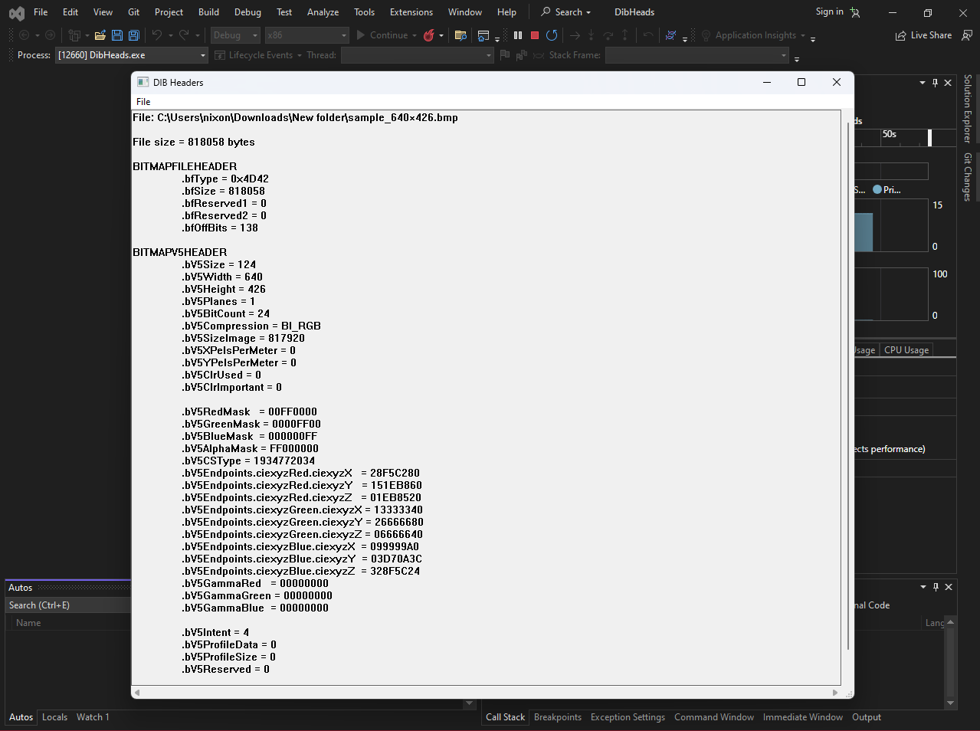

In our code, after reading the **BMP file** and parsing the DIB headers, we ended up with:

* a pointer to the **DIB header + color table**
* a pointer to the **pixel bits**

JPEG and other formats are different — BMP already matches the DIB layout, so it’s easier.

I. What SetDIBitsToDevice Does

SetDIBitsToDevice draws a **DIB directly** to a device (screen or printer).

Important:

* **No scaling**
* **1 DIB pixel = 1 device pixel**
* Image orientation is handled correctly by Windows

This function is for **simple, exact display**.

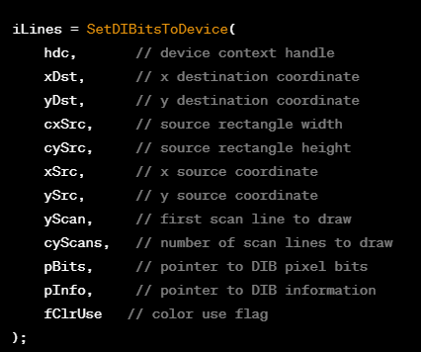

II. The Only Arguments That Really Matter

Here’s what you actually need to understand:

* **hdc**  
  The device context to draw to (screen, window, printer).
* **xDst, yDst**  
  Where the image appears on the output device (top-left corner).
* **cxSrc, cySrc**  
  Width and height of the source image (or part of it), in **pixels**.
* **xSrc, ySrc**  
  Where to start reading pixels inside the DIB.  
  Usually 0, 0.
* **yScan, cyScan**  
  Which scanlines to draw.  
  Usually draw everything.
* **pBits**  
  Pointer to the pixel data.
* **pInfo**  
  Pointer to BITMAPINFO (header + color table).
* **fClrUse**  
  Almost always DIB_RGB_COLORS.

III. Typical Call (Entire DIB)

Most programs use **these exact values**:



That draws the **entire image**, starting from the top-left.

IV. About the “Upside-Down” DIB Thing

Yes, DIB pixel data is stored **bottom-up**.

But:

* SetDIBitsToDevice already understands this
* you do **not** flip anything manually for normal use

Just remember:

* cyDib = abs(biHeight)

That’s enough.

V. Pixel Coordinates vs Logical Coordinates

Despite what some docs say:

* xSrc, ySrc, cxSrc, cySrc are **pixel values**
* not logical units
* not affected by mapping modes

Mapping modes affect **where** the image is placed,  
not its **size or orientation**.

VI. Sequential Scanline Drawing (Advanced)

The parameters:

* yScan
* cyScan

exist so Windows can:

* draw a DIB **piece by piece**
* save memory for very large images

Example use case:

* loading a huge BMP from disk
* streaming image data

For normal programs:

* yScan = 0
* cyScan = image height

Ignore this unless memory is tight.

VII. Color Table Flag (fClrUse)

* Use DIB_RGB_COLORS for normal DIBs
* Use DIB_PAL_COLORS only when working with logical palettes

Most modern code:

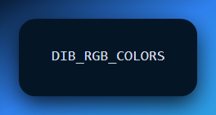

VIII. What pInfo Can Point To

Usually:

* BITMAPINFO

But Windows also supports:

* BITMAPCOREINFO
* BITMAPV4HEADER
* BITMAPV5HEADER

As long as the header is valid, Windows figures it out.

You don’t need to special-case this unless writing loaders.

IX. Return Value (Don’t Ignore This)

SetDIBitsToDevice returns:

* number of scanlines drawn

If it returns 0:

* drawing failed

Always check it.

X. Final Mental Model

* DIB already describes its own pixels
* SetDIBitsToDevice just **copies them to a device**
* no scaling
* no format conversion
* no magic

If you want:

* scaling → StretchDIBits
* speed → convert to DDB + BitBlt
* pixel editing → CreateDIBSection

SHOWDIB1.C — WHAT ACTUALLY MATTERS

The SHOWDIB1 program is a **minimal DIB viewer**.

Its purpose is simple:

* load a BMP (DIB) from disk
* keep it in memory
* display it in a window using SetDIBitsToDevice

Everything else is just standard Win32 boilerplate.

What This Program Demonstrates (That You Should Learn)

1. BMP = DIB-Friendly

BMP files already store data in **DIB layout**.

That’s why:

* BMP is easy to load
* JPEG is not (needs decoding)

This example is about **DIB handling**, not image formats.

2. DIB Is Loaded as One Memory Block

The image is loaded into memory as:

* BITMAPFILEHEADER
* followed by DIB header
* followed by pixel bits

The program then computes:

* pointer to BITMAPINFO
* pointer to pixel data
* image width and height

This is the **key DIB pattern**.

3. Display = One API Call

During WM_PAINT, the program simply calls:

* SetDIBitsToDevice
* using the stored pointers
* with no scaling
* no conversion

This shows the **purest DIB → screen path**.

4. File I/O Is Isolated (Good Design)

All file handling lives in:

* DIBFILE.C
* DIBFILE.H

That code:

* opens file dialogs
* loads the DIB into memory
* saves it back to disk

The window code does **not** care how files work.

That separation is intentional.

5. Menus Trigger DIB State Changes

* **File → Open**  
  Loads a DIB into memory
* **File → Save**  
  Writes the same memory block back to disk

Menu enable/disable logic just checks:

* “Do we currently have a DIB?”

Nothing fancy.

6. This Program Is Intentionally Incomplete

Petzold even tells you this.

Known limitations:

* no scrollbars
* no scaling
* no clipping
* no large-image handling

Those are **teaching hooks** for later chapters.

7. The Only Mental Model to Keep

SHOWDIB1 proves one thing:

**A DIB is just memory, and Windows knows how to draw it.**

Load memory → compute pointers → draw.

That’s it.

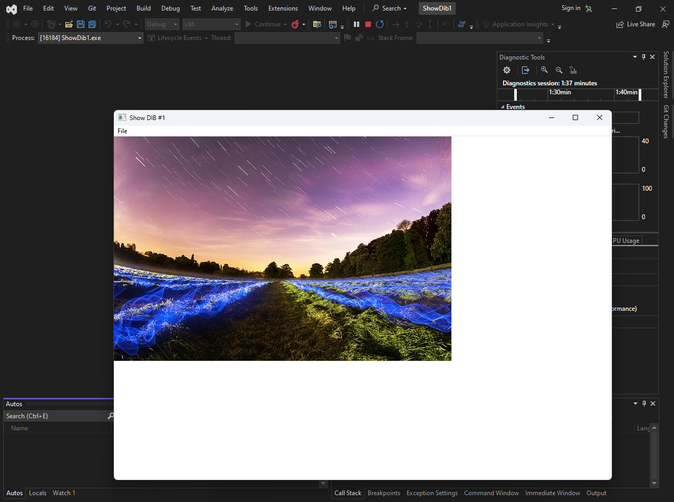

DIBS: WHEN EARLY DESIGN DECISIONS COME BACK TO HAUNT YOU

Designing OS APIs is hard — **fixing bad early decisions is worse**.  
Device-Independent Bitmaps (DIBs) are a perfect example.

Where the Problem Started (OS/2) **🧭**

In **OS/2 Presentation Manager**:

* The coordinate origin **(0,0)** is at the **bottom-left**
* Bitmaps were stored **bottom-up**
* Bitmap drawing functions also used **bottom-left coordinates**

So, if you drew a bitmap at (0,0), it appeared flush against:

* the **left**
* the **bottom** of the window

This was **internally consistent** and made sense *inside OS/2* — even if it felt weird to anyone not thinking like a mathematician.

✔️ First pixel in bitmap data  
✔️ First row in memory  
✔️ Origin (0,0)  
→ all lined up nicely

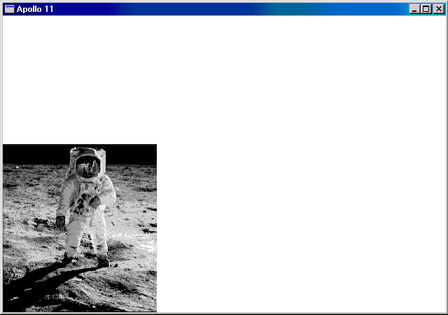

I. The Lesson **⚠️**

If the foundation is wrong, patching later just multiplies the mess.

The bottom-up DIB design worked in OS/2,  
but became **confusing and painful** when mixed with other systems and APIs.

On slow machines, you could *literally see* the bitmap being drawn **from bottom to top**.

II. Windows Enters the Scene (and Breaks Consistency)

Windows kept **bottom-up DIB storage**, but changed how things are displayed.

**Source coordinates (still OS/2-style):**

* xSrc, ySrc are measured from the **first row of DIB data**
* The **first row is the bottom of the image**

**Destination behavior (Windows-style):**

* Windows displays the **top row of the image** at (xDst, yDst)

So now:

* (xSrc, ySrc) **does NOT map** to (xDst, yDst)
* Instead, (xSrc, ySrc + cySrc − 1) maps to (xDst, yDst)

This is the core reason **DIBs feel insane** in WinAPI.

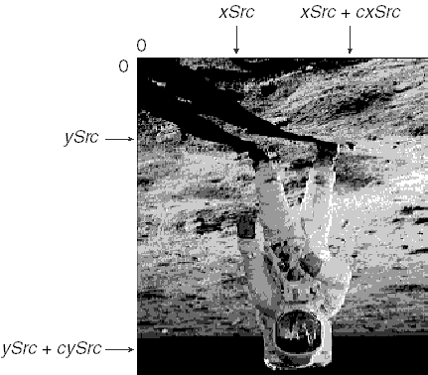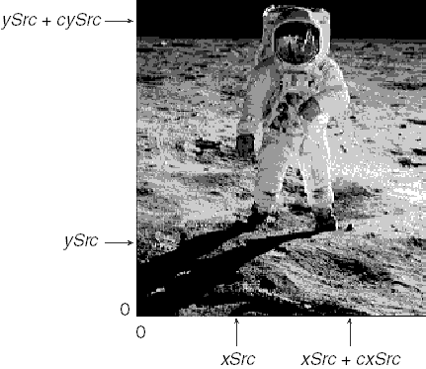

III. Why This Feels Chaotic

* DIB data starts at the **bottom**
* Image is displayed from the **top**
* Coordinates refer to **data order**, not visual order

Even worse:

* This behavior stays the same **regardless of mapping mode**
* MM_TEXT or not — the image looks the same, but the math stays cursed

IV. Top-Down DIBs (Negative biHeight): Not the Fix You Think **🔁**

If biHeight is **negative**, the DIB is **top-down**.

Sounds like a solution, right?  
Nope. 😐

Someone decided:

* Flip the rows
* Set biHeight positive
* Pretend nothing changed

The goal:  
👉 *Don’t break existing code*

The result:

* Programs **still** must handle top-down DIBs specially
* Source coordinates now have an origin at the **last row of data**
* (0,0) is:
  + not the first pixel
  + not the last pixel
  + somewhere awkward in the middle

This is a **brand-new mental model**, and not in a good way.

V. The One Smart Thing: SetDIBitsToDevice

Here’s the **one genuine win** in this whole mess 👇

**✅ Orientation-Independent Arguments**

SetDIBitsToDevice uses arguments that **don’t care** whether the DIB is:

* bottom-up **or**
* top-down

If two DIBs:

* contain the same image
* but have rows stored in opposite order

You can use the **exact same arguments** to draw the same part of the image.

🔥 This is why it works cleanly in the **APOLLO11** example.

VI. Final Takeaway (Straight Talk)

OS/2 was weird but **consistent**

Windows tried to be compatible and became **inconsistent**

DIBs are confusing because:

* data order ≠ visual order
* source ≠ destination

SetDIBitsToDevice is the rare API that **does the right thing**

MM_TEXT Mapping Mode and Coordinate Behavior

Because the arguments are used the same way every time, you don’t need to rewrite your code for different DIB orientations.

Whether the image is top-down or bottom-up, the function calls stay the same.

This makes your code **simpler, cleaner, and easier to reuse** when working with DIBs in different situations.

Below is the same information, with the **xSrc coordinates shown in code boxes**:

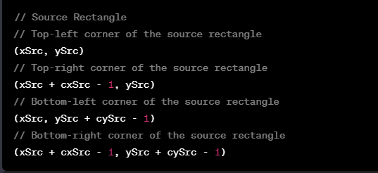

When using **MM_TEXT** mapping mode (the default pixel-based mode), source and destination rectangles don’t map in a perfectly intuitive way.

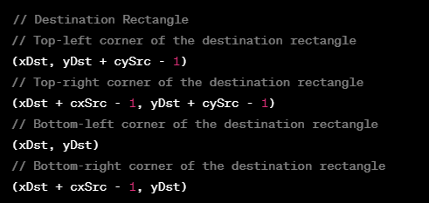

In **MM_TEXT** mode, the source point **(xSrc, ySrc)** does **not** directly map to **(xDst, yDst)**.

This makes coordinate calculations a bit more confusing compared to other mapping modes.

In other mapping modes, the mapping behaves more predictably:

* The point **(xSrc, ySrc + cySrc − 1)** maps to **(xDst, yDst)**.
* This preserves the visual appearance of the image, even though the coordinate systems differ.

Top-Down vs Bottom-Up DIBs

For **top-down DIBs**, the **biHeight** field in **BITMAPINFOHEADER** is **negative**.

This changes how source coordinates work:

* The origin starts at the **first row of pixel data**, not the last.
* This is different from **bottom-up DIBs**, where the origin is at the bottom row.

To specify a rectangle inside a **top-down DIB**, you use source coordinates like this:

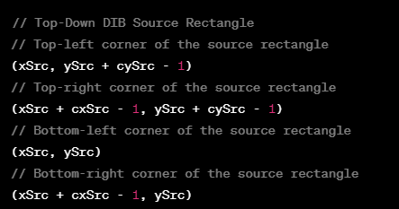

This arrangement considers the peculiarities of top-down DIBs, where the origin is at the last row of the DIB data.

No coordinate flipping is needed because the image data is already stored top-down.

**Key idea:**  
MM_TEXT mode makes source-to-destination mapping less direct, but Windows keeps the image looking correct. Top-down DIBs simplify source coordinates by matching how we naturally think about images (top-left origin).

APOLLO11 Program — What It’s Actually Demonstrating **🚀**

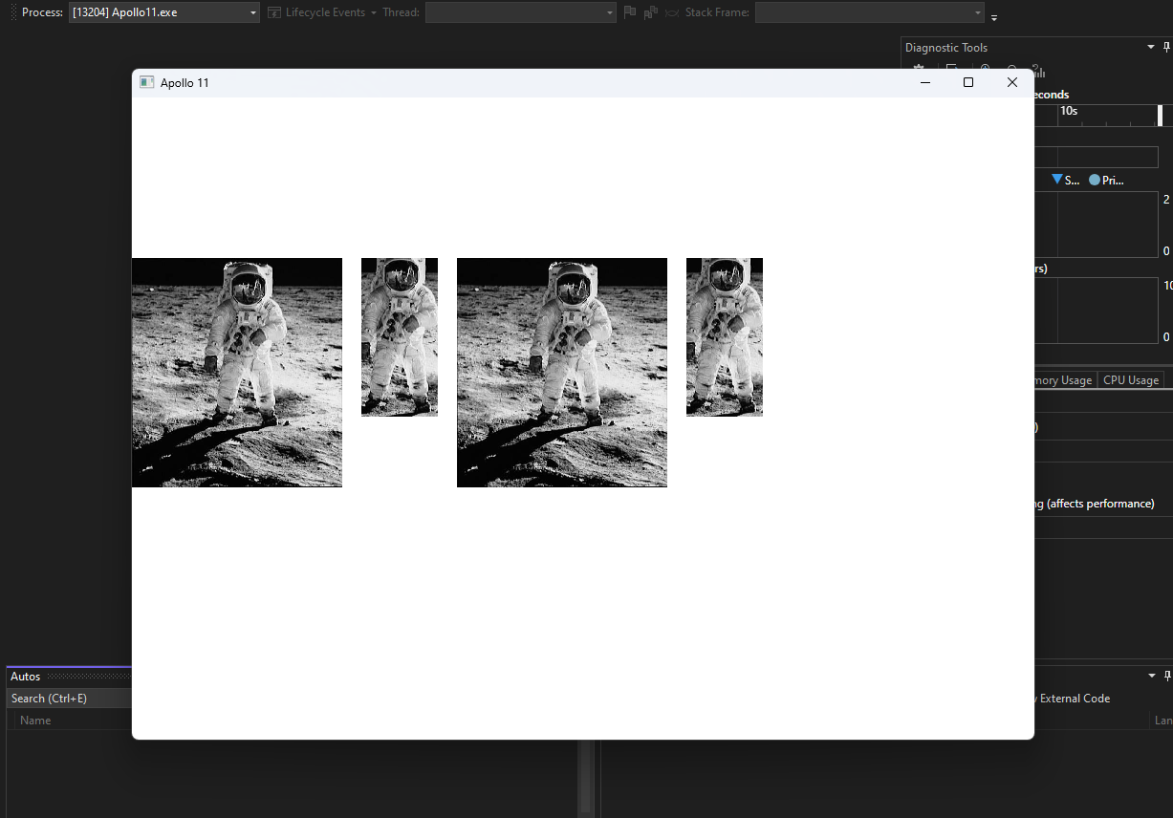

Before looking at the **APOLLO11** program, it helps to understand **why SetDIBitsToDevice exists and when it’s useful**.

This function is not magic — it’s a **reliable pipe** for pushing raw DIB pixel data onto a device context **without caring about DIB orientation**.

That’s the whole point.

I. Image Rendering (The Main Use)

SetDIBitsToDevice is commonly used to draw images directly to:

* the screen
* a window
* any device context (DC)

It efficiently copies pixel data from a DIB into the DC while correctly handling:

* bottom-up DIBs
* top-down DIBs
* mapping modes

This is exactly why APOLLO11 uses it.

II. Bitmap Copying & Sub-Regions **✂️**

You can also use SetDIBitsToDevice to:

* draw only **part** of a bitmap
* select a rectangular region using:
  + xSrc, ySrc, cxSrc, cySrc
* place it at a destination rectangle

This enables:

* cropping
* partial rendering
* overlaying one bitmap region onto another

No manual row flipping needed.

III. Printing **🖨️**

When printing images:

* the printer exposes a **device context**
* SetDIBitsToDevice can copy DIB pixels directly to it

By choosing correct coordinates and mapping modes, the image prints exactly as expected.  
This function is often used alongside other GDI printing calls.

IV. Format Conversion & Processing **🎨**

Although not its primary role, the function can be used as part of a pipeline to:

* convert color formats
* change bit depth
* move data between DIBs
* apply processing before display or storage

The key idea:  
👉 *you control the DIB, and this function just pushes pixels.*

V. Custom Drawing **🧩**

If you manually generate pixel data:

* procedural graphics
* effects
* user-generated content

You can:

1. build a DIB in memory
2. call SetDIBitsToDevice
3. blast it onto the screen or DC efficiently

This avoids slow per-pixel drawing calls.

VI. Why APOLLO11 Matters

The **APOLLO11** program exists to prove one thing:

You can use the **same arguments** to display the **same image region**,  
regardless of whether the DIB is **top-down or bottom-up**.

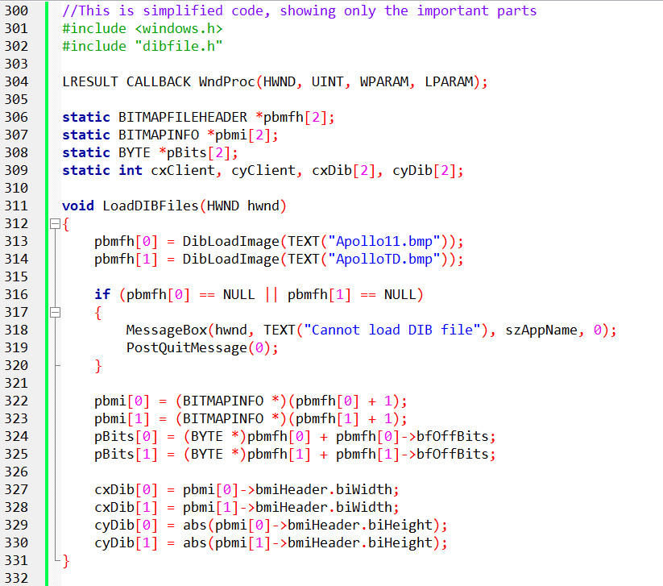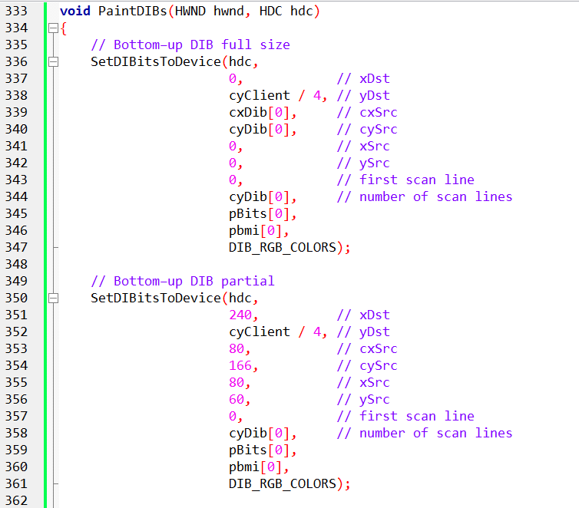

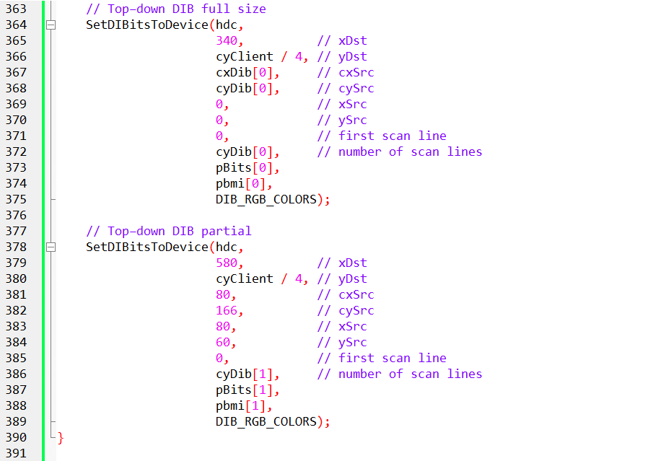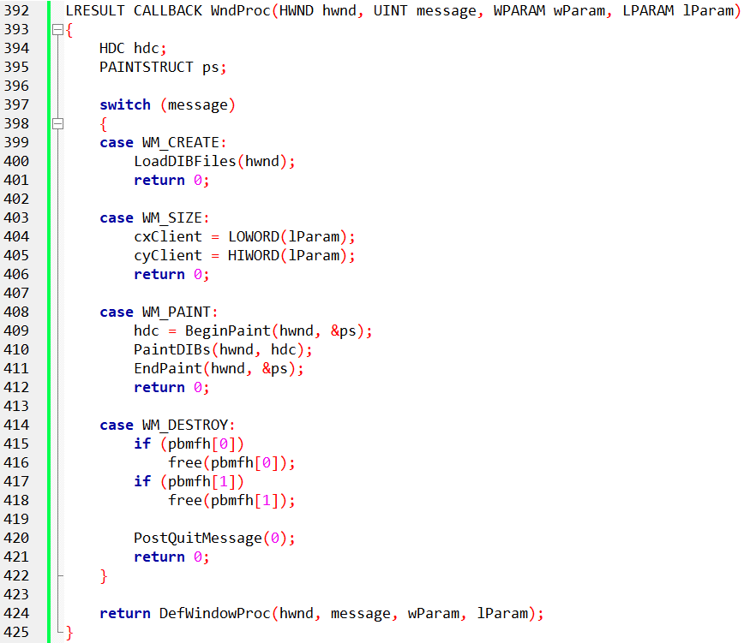

Yes, the code above contains the main parts of the program, including the LoadDIBFiles function, PaintDIBs function, and the WndProc function. Let's go through each of these functions in more detail:

LoadDIBFiles function:

This function is responsible for loading the DIB files ("Apollo11.bmp" and "ApolloTD.bmp") and extracting the necessary information from them.

It uses the DibLoadImage function from the "dibfile.h" library to load the DIB files and store the resulting BITMAPFILEHEADER structures in the pbmfh array.

If the loading of any DIB file fails (returns NULL), a message box is displayed, indicating the failure, and the program calls PostQuitMessage to post a quit message and terminate the application.

The function then extracts the BITMAPINFO structures and the pixel data (pBits) for each DIB from the pbmfh array.

Additionally, it stores the width and height of each DIB in the cxDib and cyDib arrays, respectively.

PaintDIBs function:

This function is responsible for painting the loaded DIBs onto the window's device context (hdc).

It uses the SetDIBitsToDevice function to transfer pixel data from the DIBs to the device context and display them on the window.

Four calls to SetDIBitsToDevice are made in this function, each displaying a different part of the DIBs at specified coordinates on the window.

The parameters of SetDIBitsToDevice are set accordingly to specify the destination position, source dimensions, source data, and color format for each call.

WndProc function:

This function is the window procedure and handles various messages sent to the window.

In the WM_CREATE message case, the LoadDIBFiles function is called to load and extract information from the DIB files.

In the WM_SIZE message case, the client area dimensions (cxClient and cyClient) are updated based on the new size of the window.

In the WM_PAINT message case, painting is initiated by obtaining the device context (hdc) using BeginPaint. Then, the PaintDIBs function is called to display the DIBs on the window. Finally, EndPaint is called to finish the painting process.

In the WM_DESTROY message case, the program frees the memory allocated for the loaded DIBs using free and calls PostQuitMessage to post a quit message and terminate the application.

This code sets up a window, loads DIB files, and displays different parts of the DIBs onto the window using the SetDIBitsToDevice function. The LoadDIBFiles function handles the loading of DIB files and extracting relevant information, while the PaintDIBs function performs the actual rendering of the DIBs onto the window. The WndProc function handles the window messages, including initialization, resizing, painting, and termination of the application.

The program is designed to load and display two DIBs: "APOLLO11.BMP" (in a bottom-up orientation) and "APOLLOTD.BMP" (in a top-down orientation). Both DIBs have a width of 220 pixels and a height of 240 pixels. It's worth noting that when determining the DIB's width and height from the header information structure, the program uses the abs function to obtain the absolute value of the biHeight field.

When displaying the DIBs, whether in full size or in partial views, the xSrc, ySrc, cxSrc, and cySrc coordinates remain the same regardless of which bitmap is being displayed. This means that the specific region of the DIB being shown is consistent across both DIBs.

The program utilizes the SetDIBitsToDevice function to transfer the pixel data from the DIBs to the device context, thereby displaying them on the window. The function is called four times within the PaintDIBs function, each with different parameters to display distinct portions of the DIBs at specified coordinates on the window.

By following this approach, the program successfully loads and renders the two DIBs onto the window, reflecting their respective orientations (bottom-up and top-down).

For a visual representation of the results mentioned above, you can refer to Figure 15-7 below.

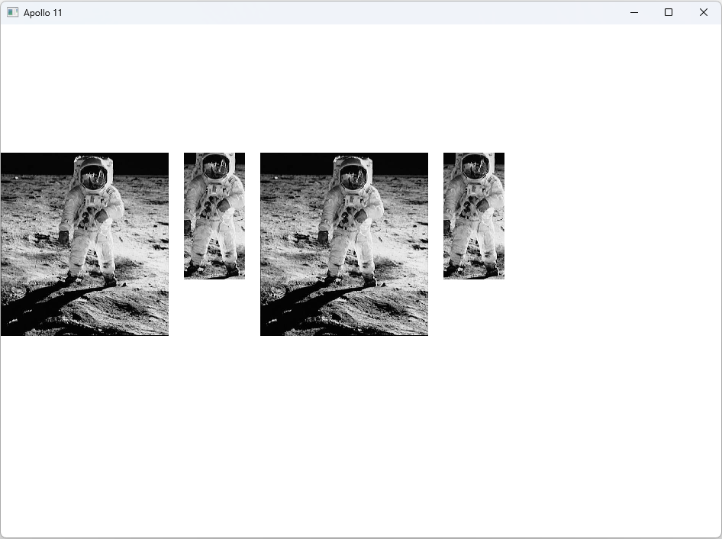

When working with the SetDIBitsToDevice function, it's important to keep in mind that certain arguments, such as the "first scan line" and "number of scan lines," should not be modified. It is also advised not to attempt to alter the pBits argument to point to a specific area of the DIB for display.

The confusion surrounding these aspects of the Windows API does not arise from a lack of effort on the part of developers but rather from inherent inconsistencies in the API's definition. If you find it confusing, it's because it is indeed confusing.

When reading statements in the Windows documentation, such as the one for SetDIBitsToDevice, which states that "the origin of a bottom-up DIB is the lower-left corner of the bitmap; the origin of a top-down DIB is the upper-left corner," it's important to note that this statement is both ambiguous and incorrect.

A clearer explanation would be as follows: The origin of a bottom-up DIB is the bottom-left corner of the bitmap image, representing the first pixel of the first row of bitmap data. On the other hand, the origin of a top-down DIB is also the bottom-left corner of the bitmap image, but in this case, it refers to the first pixel of the last row of bitmap data.

The challenges become more pronounced when writing functions to access individual bits of a DIB, particularly when consistency with specifying coordinates for displaying partial DIB images is required.

A suggested solution, which will be implemented in a DIB library in Chapter 16, involves consistently referencing DIB pixels and coordinates as if the (0,0) origin corresponds to the leftmost pixel of the top row of the DIB image when it is correctly displayed.

MEMORY EFFICIENCY AND USE CASES:

Sequential display shines when memory conservation is crucial or when working with DIBs from slow sources. It's ideal for:

Handling large DIBs that might strain available memory.

Displaying DIBs as they're being acquired or transmitted, optimizing responsiveness.

Minimizing memory footprint in resource-constrained environments.

Mechanism Under the Hood:

SetDIBitsToDevice holds the key to sequential display. It accepts:

* pBits: A pointer to the pixel data to display.
* yScan: The starting row within the DIB.
* cyScans: The number of rows to display.

Multiple calls to this function, each with different yScan values, progressively reveal the DIB's content.

Memory Management Strategies:

To maximize efficiency, allocate memory strategically:

* Store the DIB's information section (BITMAPINFOHEADER and color table) for reference.
* Allocate memory for only a portion of the pixel data, adjusting based on the current display block.

This approach significantly reduces memory overhead compared to loading the entire DIB at once.

Trade-offs and Considerations:

Close Coupling: Sequential display often necessitates closer integration between data acquisition and display code. This might increase code complexity.

Performance Impact: Alternating between data acquisition and display can introduce overhead, potentially slowing down overall processing.

Functionality Limitations: Currently, only SetDIBitsToDevice supports sequential display. StretchDIBits lacks this feature, so displaying DIBs at different pixel sizes requires alternative approaches.

Alternatives for Rescaling DIBs:

While StretchDIBits doesn't directly support sequential display, explore workarounds:

Make multiple calls to StretchDIBits, each targeting a portion of the DIB.

Modify the BITMAPINFOHEADER structure within each call to achieve the desired scaling effect.

Practical Demonstration:

The SEQDISP program, offers a hands-on example of sequential display implementation. Refer to it for practical guidance.

Sequential display provides a powerful technique for memory-efficient DIB handling.

Understanding its benefits, trade-offs, and implementation details empowers informed decisions when working with bitmap images in various scenarios.

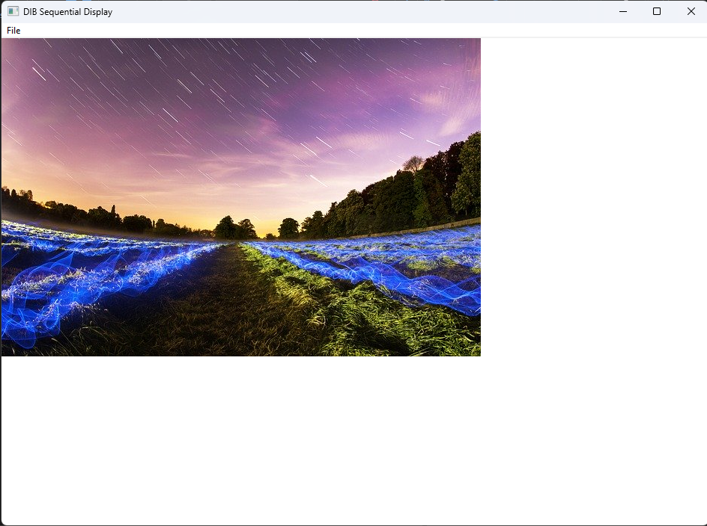

The SEQDISP program, authored by Charles Petzold, is designed for the sequential display of Device Independent Bitmaps (DIBs). Upon opening a Bitmap (BMP) file, the program reads its header and pixel data, accommodating variations in DIB formats, including top-down orientation. It then sequentially displays the image row by row on the window, considering the DIB's specific characteristics such as width, height, and bit count. The program provides visual feedback during the file loading process and reverts to a standard arrow cursor upon completion. In contrast to the previous program, APOLLO11, which focused on displaying specific portions of DIBs and addressing complications in DIB handling, SEQDISP prioritizes the sequential display of entire DIBs, showcasing a different approach to handling and presenting bitmap images.

*I then observed the bmp file being loaded from bottom to top very quickly?*

The observed bottom-to-top loading behavior in the SEQDISP program is a consequence of the program's handling of top-down DIBs. In certain DIB formats, the pixel data starts from the last row (bottom) and progresses upward, contrary to the conventional bottom-up orientation where pixel data begins at the top. This peculiarity is particularly relevant when dealing with image data that is stored in a top-down manner, as indicated by the negative height in the DIB header. During the loading process, the program adjusts its display strategy to correctly render the image, resulting in the observed fast rendering from bottom to top. This behavior underscores the program's flexibility in accommodating different DIB formats and orientations.

Additionally, when opening a bitmap file in the SEQDISP program, you should note its ability to dynamically handle various bitmap formats and orientations. The program is designed to interpret the bitmap file's structure, accounting for both bottom-up and top-down pixel data arrangements. It efficiently reads the file, adapts to the specified DIB format, and displays the image appropriately on the window. The SEQDISP program showcases a robust implementation that accommodates the complexities of different bitmap configurations, offering a seamless visual representation regardless of the specific details encoded in the file.

Stretching DIBs to Fit with StretchDIBits

StretchDIBits allows you to stretch or shrink a DIB to fit a desired size on the output device.

It offers more flexibility than SetDIBitsToDevice, which only performs pixel-to-pixel display.

Syntax:

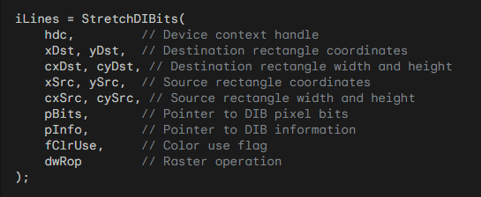

Key Differences from SetDIBitsToDevice:

Destination Rectangle Size: StretchDIBits includes parameters for destination rectangle width and height (cxDst, cyDst).

Sequential Display: StretchDIBits doesn't have the option to reduce memory usage by displaying the DIB sequentially.

Raster Operation: StretchDIBits includes a raster operation parameter (dwRop) to control how pixels are combined with the output device.

Signed Width and Height: Source and destination widths and heights (cxSrc, cySrc, cxDst, cyDst) can be negative to flip the DIB horizontally or vertically.

Mapping Modes and Flipping:

StretchDIBits is fully affected by the mapping mode of the destination device context.

You can use negative widths or heights to compensate for flipping effects caused by mapping modes.



The -1 terms in the destination rectangle table are approximate and can vary depending on stretch and transforms.

The Sign functions in the expressions for flipping aren't standard C functions; their implementation is context-specific.

Flipping DIBs Using Mapping Modes and Width/Height:

Mapping Modes (xMM, yMM):

* Indicate the orientation of the mapping mode.
* xMM is 1 for values of x increasing to the right, -1 for increasing to the left.
* yMM is 1 for values of y increasing downward, -1 for increasing upward.

Flipping Expressions:

* if (!Sign(xMM × cxSrc × cxDst)): DIB is flipped on its vertical axis (mirror image).
* if (!Sign(yMM × cySrc × cyDst)): DIB is flipped on its horizontal axis (upside down).

You can also use negative widths or heights in StretchDIBits to flip the DIB intentionally.

Additional Considerations:

The Sign functions mentioned in the expressions for flipping aren't standard C functions. Their implementation is likely specific to the context in which they're used.

SHOWDIB2 PROGRAM:

The provided code is a Windows application written in C that displays Device Independent Bitmaps (DIBs) in various ways, such as normal, centered, stretched, or isotropically stretched. Let's break down the DIB-related portions of the code:

DIB Loading and Initialization:

The program utilizes functions from a file named "dibfile.h" for handling DIB operations. In the WM_COMMAND message handler, when the user selects "Open" from the File menu (IDM_FILE_OPEN), the program prompts the user to choose a DIB file using DibFileOpenDlg. It then loads the selected DIB into memory using DibLoadImage. The program checks whether the DIB is loaded successfully and retrieves pointers to the DIB's information structure (pbmi) and pixel data (pBits). The width and height of the DIB are obtained from the DIB header.

Displaying DIBs:

The actual rendering of the DIB on the window occurs in the WM_PAINT message handler. The ShowDib function is called, passing the device context (hdc), DIB information structure (pbmi), pixel data (pBits), DIB width and height (cxDib and cyDib), and client area dimensions (cxClient and cyClient). The way the DIB is displayed depends on the value of wShow, which is set based on the user's choice from the "Show" menu.

Printing DIBs:

If the user selects the "Print" option from the File menu (IDM_FILE_PRINT), the program prepares for printing. It checks whether the printer supports bitmaps and obtains the printer's device context. The ShowDib function is then called to print the DIB on the printer's page.

Copying and Cutting DIBs:

The program allows the user to copy (IDM_EDIT_COPY) or cut (IDM_EDIT_CUT) the DIB to the clipboard. The selected operation allocates a global memory block (hGlobal) and copies the packed DIB into it. The program then transfers this data to the clipboard, making it available for pasting into other applications.

Deleting and Freeing Resources:

If the user chooses to delete (IDM_EDIT_DELETE) the DIB, the allocated memory is freed, and the client area is invalidated for an update. Additionally, when the program is closed (WM_DESTROY), it checks if a DIB is loaded and frees the associated memory.

In the above explanations I only focused on the DIBs portion of the program, coz the rest is simple stuff. Let’s see this program in a video…



Displaying DIBs:

The ShowDib function is highlighted as a key element in the program, responsible for displaying the DIB in different ways based on menu selections. It uses SetDIBitsToDevice for normal and centered display and StretchDIBits for stretched and isotropically stretched options. The distinction between these modes affects how the DIB is presented in the client area.

Copying DIBs to Clipboard:

The process of copying a DIB to the clipboard is explained. It involves making a copy of the packed-DIB memory block in global shared memory, and the clipboard data type used is CF_DIB. However, the note mentions that the code does not show how to copy a DIB from the clipboard, indicating that this functionality may require additional logic. This is a common scenario when working with clipboard operations.

Deficiencies and Future Improvements:

The notes point out certain deficiencies in the program. For instance, there are potential issues when displaying DIBs in a 256-color video mode, where colors may not appear correctly. This is attributed to the need for handling the palette, which is a topic reserved for the next chapter. Additionally, a speed problem, especially in Windows NT, is acknowledged, and the resolution of this issue is promised in the upcoming chapter. The note also hints at addressing the display of larger DIBs with the addition of scroll bars.

Palette Handling and Color Display:

The mention of deficiencies related to 256-color video modes indicates that the program currently lacks proper handling for displaying colors in such environments. The note hints at the need to work with palettes to address this issue, suggesting that this aspect will be covered in more detail in the subsequent chapter.

Performance Considerations:

The note acknowledges a speed problem, particularly in Windows NT, without providing specific details. It promises a solution or optimization strategy in the next chapter. This indicates an awareness of potential performance issues and a commitment to addressing them in future discussions.

COLOR CONVERSION, PALETTES, AND PERFORMANCE IN DIB DISPLAY: A DEEP DIVE

Following the Pixel Bits: Understanding color conversion is crucial for optimizing bitmap display performance. The DIB format differs from video display memory, necessitating conversions during SetDIBitsToDevice or StretchDIBits calls. Millions of pixels might be involved, impacting performance significantly.

Trivial Conversions:

24-bit DIB on 24-bit display: minimal byte reordering if necessary.

16-bit DIB on 24-bit device: bit-shifting and padding.

24-bit DIB on 16-bit device: bit-shifting and truncation.

4/8-bit DIB on 24-bit device: color table lookup, potential byte reordering.

Challenging Conversions:

High-bit DIBs (16/24/32-bit) on 4/8-bit displays: nearest-color search for each pixel, involving loops and calculations. This is computationally expensive compared to simpler conversions.

Nearest-color search: finding the closest device color to the DIB pixel within the RGB color cube (represented as a 3D space). Distance metric involves complex calculations, although square root is not required for RGB comparisons.

8-bit DIB on 8-bit device: nearest-color search only needed for unique DIB colors, not every pixel.

Performance Optimization:

Avoid displaying high-bit DIBs on 4/8-bit displays using SetDIBitsToDevice/StretchDIBits.

Pre-convert DIBs to 8-bit DIBs or DDBs for faster BitBlt/StretchBlt display on any video mode.

DDBs offer significant performance boosts compared to DIBs for most display purposes.

8-bit Palette Limitations:

Windows in 8-bit mode restricts displayed DIBs to a maximum of 20 colors.

The Palette Manager (discussed later) plays a crucial role in exceeding this limit.

Windows NT Performance Differences:

Windows NT's client/server architecture can lead to slower DIB display compared to Windows 98 for similar video modes due to increased data transfer overhead.

Converting DIBs to DDBs or using CreateDIBSection (introduced later) can improve performance in such scenarios.

Key Takeaways:

Color conversion between DIBs and video memory significantly impacts performance.

Understanding conversion types and their complexities is crucial for optimization.

Pre-converting to lower bit depths (8-bit DIB or DDB) offers substantial performance gains.

Windows NT architecture requires specific considerations for optimal DIB display.

Let’s take these notes a bit deeper…

To achieve optimal performance in bitmap display, it is crucial to understand the process of color conversion, especially when dealing with Device Independent Bitmaps (DIBs) and their presentation on device-dependent video displays.

The analogy to "Follow the pixel bits" is drawn, emphasizing the importance of tracking how color conversion occurs and when it takes place during functions like SetDIBitsToDevice or StretchDIBits.

The DIB exists in a device-independent format, while the video display memory is likely to be in another format.

During the mentioned function calls, each pixel, potentially numbering in the millions, must be converted from the device-independent format to the device-dependent format. The complexity of this conversion varies depending on the color depths involved.

For instance:

Displaying a 24-bit DIB on a 24-bit video display may require a simple rearrangement of the red, green, and blue bytes.

Presenting a 16-bit DIB on a 24-bit device involves bit-shifting and padding.

Displaying a 4-bit or 8-bit DIB on a 24-bit device requires a lookup in the DIB's color table and potential byte reordering.

However, when attempting to display a higher bit-depth DIB (e.g., 16-bit, 24-bit, or 32-bit) on a lower bit-depth video display (e.g., 4-bit or 8-bit), a different type of color conversion is necessary.

A nearest-color search must be performed for each pixel, involving a loop and a calculation. The RGB color space can be visualized as a cube, and finding the closest color involves determining the shortest distance between two points in this cube.

The distance formula between two colors R1G1B1 and R2G2B2 is given by:



However, in practice, the square root part of the calculation is often omitted for efficiency. Each pixel must be compared to all the colors on the device to find the closest match, making this process computationally intensive.

For performance reasons, the note advises against displaying high bit-depth DIBs on low bit-depth video displays using SetDIBitsToDevice or StretchDIBits.

Instead, conversion to an 8-bit DIB or, for even better performance, to an 8-bit Device Dependent Bitmap (DDB) is recommended. Converting most DIBs to DDBs and utilizing BitBlt and StretchBlt for display purposes can significantly enhance speed.

In situations where Windows is operating in an 8-bit video display, there may be limitations in displaying DIBs with their full range of colors, restricting them to just 20 colors. Overcoming this limitation involves utilizing the Palette Manager, a topic to be covered in the next chapter.

Additionally, the note addresses performance differences in displaying large DIBs between Windows 98 and Windows NT on the same machine.

Windows NT's client/server architecture incurs a penalty for handling large amounts of data across the API.

The recommended solution is, once again, to convert the DIB to a DDB. The CreateDIBSection function, discussed later, is introduced as a tool specifically designed to assist in this scenario.

DDBs AND DIBs MEET(union)

The advantages and limitations of working with Device-Independent Bitmaps (DIBs) and Device Dependent Bitmaps (DDBs) and suggests a possible solution to overcome these limitations. Here's a deeper explanation:

DIBs offer direct access to every bit, byte, and pixel of the image, providing flexibility in examining and modifying the data. Functions like SetDIBitsToDevice and StretchDIBits allow you to draw DIBs on output devices by directly manipulating the pixel data.

However, there are some limitations to working with DIBs. Unlike DDBs, there doesn't appear to be a straightforward way to draw images directly on DIBs using GDI functions. In other words, you can't use functions like BitBlt and StretchBlt to draw on DIBs as efficiently as you can with DDBs.

Additionally, the performance of SetDIBitsToDevice and StretchDIBits functions may not be as fast as BitBlt and StretchBlt, especially on systems like Windows NT and when there are many nearest-color searches involved (e.g., displaying 24-bit DIBs on 8-bit video boards).

To overcome these limitations, one possible solution is to convert DIBs into DDBs. By converting a DIB into a DDB, you can take advantage of the faster BitBlt and StretchBlt functions for drawing and displaying the image.

Converting a DIB to a DDB involves creating a bitmap object that matches the characteristics of the DIB, such as size and color depth. Then, you can use functions like SetDIBitsToDevice to transfer the pixel data from the DIB to the DDB.

Once the DIB is converted to a DDB, you can use BitBlt and StretchBlt functions for efficient drawing and displaying operations on output devices.

Converting between DIBs and DDBs can be advantageous when you need to display a DIB multiple times or when performance is crucial, especially on systems where DIB drawing functions may be slower.

It's important to note that the decision to convert between DIBs and DDBs depends on specific requirements and trade-offs between flexibility and performance. Depending on the situation, you may choose to work directly with DIBs or opt for conversion to DDBs for improved drawing efficiency.

Creating a (DDB) from a (DIB)

Creating a Device-Dependent Bitmap (DDB) from a Device-Independent Bitmap (DIB) involves using the CreateDIBitmap function in Windows. There are two approaches to achieve this, and the syntax for the CreateDIBitmap function includes several parameters that dictate the characteristics of the resulting bitmap.

Using CreateCompatibleBitmap:

One way to create a DDB from a DIB is to use CreateCompatibleBitmap. This involves creating a GDI bitmap object of the same size as the DIB and compatible with the video display. The process includes the following steps:

* Use CreateCompatibleBitmap to create a GDI bitmap object.
* Select the bitmap object into a memory device context.
* Call SetDIBitsToDevice to draw on the memory DC, resulting in a DDB with the same image as the DIB but with color organization compatible with the display.

Using CreateDIBitmap:

Alternatively, the CreateDIBitmap function can be employed for the same purpose with fewer steps. The function's syntax is as follows:

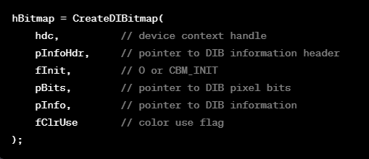

* pInfoHdr is a pointer to a BITMAPINFOHEADER structure.
* pInfo is a pointer to a BITMAPINFO structure (includes BITMAPINFOHEADER and color table).
* The fClrUse parameter can be DIB_RGB_COLORS or DIB_PAL_COLORS.

Notably, despite its name, CreateDIBitmap does not create a Device-Independent Bitmap; instead, it creates a Device-Dependent Bitmap from a Device-Independent specification. The function returns a handle to a GDI bitmap object, similar to other bitmap creation functions like CreateBitmap, CreateBitmapIndirect, and CreateCompatibleBitmap.

The simplest form of calling CreateDIBitmap involves passing only a pointer to a BITMAPINFOHEADER structure (without the color table), resulting in the creation of a monochrome GDI bitmap object.

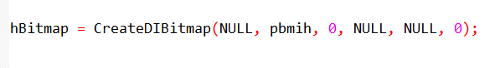

Another form includes providing a device context (hdc), creating a DDB that is compatible with the specified device context.

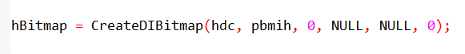

In the simplified forms of CreateDIBitmap, where the third argument is CBM_INIT, the pixel bits of the resulting Device-Dependent Bitmap (DDB) remain uninitialized.

In this case, Windows uses the last three arguments of CreateDIBitmap to initialize the bitmap bits.

The pInfo argument is a pointer to a BITMAPINFO structure that includes a color table, and the pBits argument is a pointer to an array of bits in the color format indicated by the BITMAPINFO structure.

These bits are then converted to the color format of the device, similar to what happens in SetDIBitsToDevice.

The following code demonstrates how the entire CreateDIBitmap function could be implemented based on this logic:

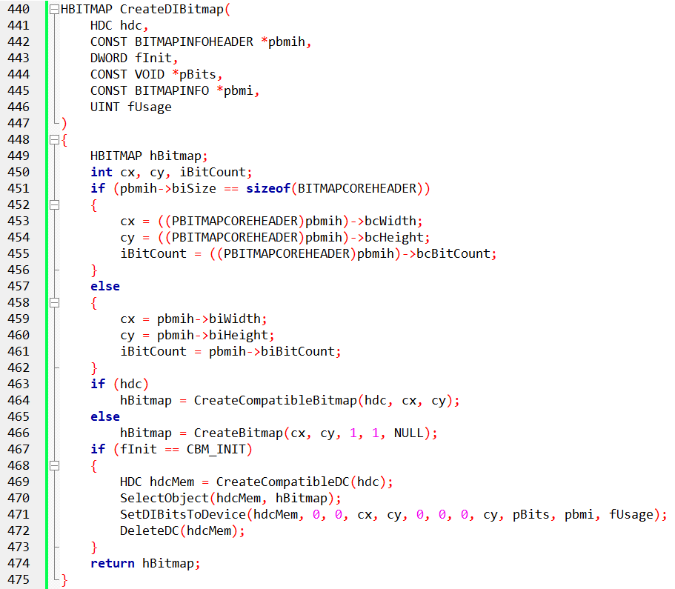

This code checks whether the bitmap header is of type BITMAPCOREHEADER or BITMAPINFOHEADER and then creates a compatible bitmap using CreateCompatibleBitmap or CreateBitmap.

If the initialization flag is set to CBM_INIT, it creates a compatible device context, selects the bitmap into the device context, and uses SetDIBitsToDevice for initialization.

It's crucial to note that if you're displaying a DIB only once and are concerned about the performance of SetDIBitsToDevice, using CreateDIBitmap followed by BitBlt or StretchBlt may not offer significant advantages.

Both SetDIBitsToDevice and CreateDIBitmap involve color conversion, making the overall time required comparable. However, if you intend to display the DIB multiple times, especially when processing WM_PAINT messages, the conversion performed by CreateDIBitmap can become more efficient.

DIBCONV PROGRAM

The DIBCONV program, depicted in Figure 15−10, provides an example of using SetDIBitsToDevice to convert a DIB file to a DDB, illustrating practical usage of the color conversion process.

Let's delve into the specific portion of the code that handles the conversion of a Device-Independent Bitmap (DIB) to a Device-Dependent Bitmap (DDB) in the DIBCONV.C program.

DIB to DDB Conversion Process:

1. File Open Dialog:

The application begins by initializing the Open File Dialog (ofn) in the WM_CREATE message. This dialog is later used to prompt the user for a Bitmap file.

2. File Open Command:

When the user selects the "Open" option from the File menu (IDM_FILE_OPEN), the program triggers the File Open Dialog. Once the user selects a Bitmap file, the program proceeds to convert the DIB to a DDB.

3. DIB File Reading:

The selected Bitmap file is opened, and its contents are read into memory. The program performs necessary validation checks, ensuring the file is a valid Bitmap file (BM signature in the BITMAPFILEHEADER and proper file size).

4. DIB to DDB Conversion:

The CreateBitmapObjectFromDibFile function is then called. This function takes the following steps:

* File Handling: The file is opened and read into memory. Various checks are performed to ensure the validity of the file, such as verifying the file type and size.
* Create DDB: Using the CreateDIBitmap function, a DDB is created based on the DIB data. The function initializes the DDB with the color information and pixel data from the DIB.

5. Painting the DDB:

Upon successful creation of the DDB, the program uses the BitBlt function to paint the DDB onto the client area of the window. This is done in the WM_PAINT message.

6. Error Handling:

If any issues occur during the file reading or DIB to DDB conversion process, appropriate error messages are displayed using message boxes.

7. Resource Definitions:

The resource file (DIBCONV.RC) contains definitions for the File menu and its items, including the "Open" option.

8. Resource Header Definitions:

The resource header file (RESOURCE.H) includes symbolic constants for menu items, such as IDM_FILE_OPEN.

DIB to DDB Conversion Explanation:

The conversion process involves creating a DDB from a DIB obtained from a Bitmap file. The crucial function, CreateBitmapObjectFromDibFile, encapsulates the steps to handle file I/O, validate the Bitmap file, and convert the DIB to a DDB using the CreateDIBitmap function.

The DDB is then painted onto the window's client area in response to the "Open" command. This conversion is vital for displaying images efficiently, as DDBs are device-dependent and more suitable for direct rendering on the screen. The process encapsulates essential concepts in handling image data in Windows applications.

.bmp file loads okay.

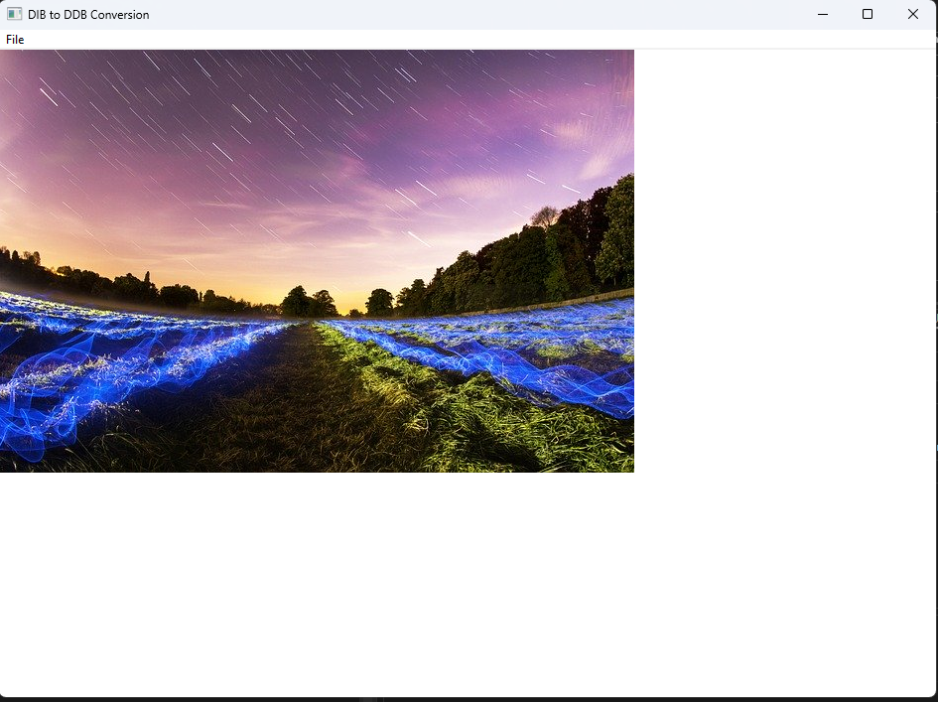

Other files don’t load.

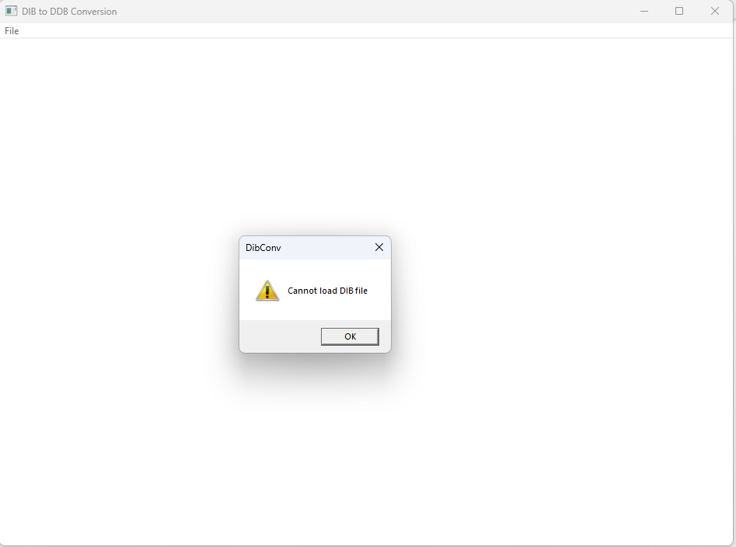

Why doesn't it load any other file apart from bmp files?

The limitation to loading only BMP files is inherent in the design and implementation of the CreateBitmapObjectFromDibFile function. Let's look at the relevant part of the code:

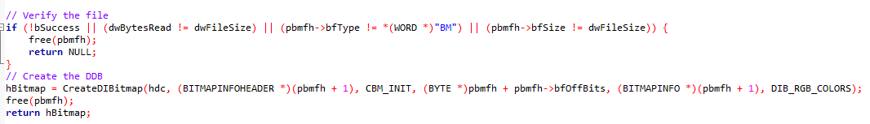

In this code, the verification step checks whether the file is a valid BMP file by comparing the bfType field in the BITMAPFILEHEADER structure with the expected value "BM".

If this check fails, the function immediately returns NULL, indicating that the file is not a valid BMP file.

For a more general-purpose file loader that can handle various image formats, you would need a more robust method of determining the file type and parsing the image data accordingly.

BMP files have a specific structure, and this code assumes that structure. To support other formats like JPEG, PNG, or GIF, you would need to implement additional logic to identify and handle the structure of those file types.

This typically involves reading the file headers and potentially using external libraries or APIs designed for image format recognition and decoding.

DIBCONV.C CONTINUED: A Self-Contained Image Conversion Program

DIBCONV.C stands as a self-contained program that necessitates no prior files for execution. Its main functionality lies in responding to the sole menu command, "File Open," where the WndProc function invokes the CreateBitmapObjectFromDibFile function.

This function, in turn, reads the entire file into memory and forwards pointers to the memory block to the CreateDIBitmap function. The function then returns a handle to the bitmap, allowing the memory block containing the Device-Independent Bitmap (DIB) to be subsequently freed.

During the handling of the WM_PAINT message, WndProc selects the bitmap in a compatible memory device context and employs BitBlt instead of SetDIBitsToDevice to display the bitmap on the client area. The dimensions of the bitmap are acquired by calling GetObject with the BITMAP structure on the bitmap handle.

Noteworthy is the fact that the initialization of the Device-Dependent Bitmap (DDB) pixel bits is unnecessary during the creation of the bitmap through CreateDIBitmap. Instead, this can be deferred and accomplished later by utilizing the SetDIBits function.

This function, presented below, accepts parameters for the device context handle, bitmap handle, starting scan line, the number of scan lines to convert, a pointer to pixel bits, DIB information, and a color use flag.

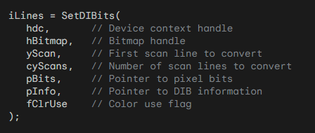

In this process, the function employs the color table in the BITMAPINFO structure to perform the conversion of bits into the device-dependent format.

The requirement for the device context handle is contingent upon whether the last argument is set to DIB_PAL_COLORS.

This approach allows for flexibility in initializing the pixel bits, offering control over the color conversion process in a manner conducive to the specific requirements of the application.

Breakdown of the SetDIBits function:

Purpose: Transfers color data (pixel bits) from a device-independent bitmap (DIB) to a device-dependent bitmap (DDB) within a specified device context (DC).

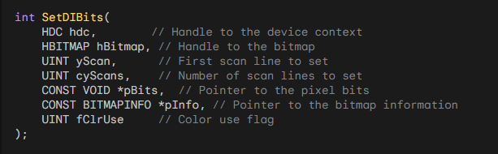

Parameters:

* hdc: The handle to the device context where the bitmap is displayed.
* hBitmap: The handle to the DDB receiving the pixel data.
* yScan: The starting scan line (row) within the bitmap to begin the transfer.
* cyScans: The number of scan lines to transfer.
* pBits: A pointer to the array of pixel bits within the DIB.
* pInfo: A pointer to a BITMAPINFO structure containing information about the DIB's format and colors.
* fClrUse: A flag indicating the color format of the DIB (usually DIB_RGB_COLORS or DIB_PAL_COLORS).

Return Value: The number of scan lines successfully transferred.

Safety Considerations:

* Memory Management: Ensure proper allocation and deallocation of memory for bitmap structures and pixel data to avoid memory leaks and potential security vulnerabilities.
* Data Validation: Validate the integrity of input data (e.g., pBits and pInfo) to prevent buffer overflows or invalid memory access.
* Error Handling: Implement robust error handling mechanisms to gracefully handle unexpected situations and prevent program crashes or data corruption.
* Usage Within Scope: Use SetDIBits only within its intended scope and avoid misuse for unintended purposes.

SetDIBits is primarily used for DIB-to-DDB transfers. For DDB-to-DIB transfers, consider GetDIBits. Always refer to official documentation for detailed usage guidelines and safety considerations.

Breakdown of the GetDIBits function

The GetDIBits function is similar to SetDIBits but serves the reverse purpose. It allows you to retrieve the pixel data and DIB information from a bitmap (DDB) and store it in a DIB.

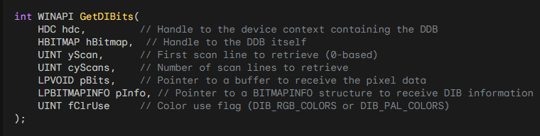

The function takes several parameters:

* hdc: The handle to the device context associated with the bitmap.
* hBitmap: The handle to the bitmap.
* yScan: The index of the first scan line to retrieve.
* cyScans: The number of scan lines to retrieve.
* pBits: A pointer to the buffer where the pixel data will be stored (output).
* pInfo: A pointer to the structure where the DIB information will be stored (output).
* fClrUse: A flag indicating how to interpret color indices.

When converting a DDB to a DIB using GetDIBits, it's important to note that some information may be lost during the conversion. The amount of information lost depends on the specific video mode under which Windows is running during the conversion.

In general, it's not recommended to rely on GetDIBits as a way to obtain the original bitmap data if the bitmap handle is the only available information. This is because the conversion process from DDB to DIB and back may not yield the exact original bitmap due to potential information loss.

GetDIBits can be useful in situations such as screen captures, where you want to retrieve the pixel data and DIB information from the screen bitmap.

The function is not demonstrated in detail, but you can refer to Knowledge Base article Q80080 for more information on screen captures and the usage of GetDIBits.

It's worth noting that in many cases, automatic conversion to DIBs is provided by the clipboard, reducing the need to use GetDIBits for bitmap data retrieval.

GetDIBits is not a perfect reversal of SetDIBits. Converting a DIB to a DDB and back can lead to information loss due to device-specific optimizations and color space adjustments.

The actual information loss depends on the video mode and hardware capabilities.

GetDIBits is most useful for capturing screen data (like BLOWUP in Chapter 14) or specific scenarios where the original DIB information is unavailable.

The clipboard often provides automatic DIB conversion, making GetDIBits unnecessary for clipboard operations.

In summary, GetDIBits is a function that allows you to convert a DDB to a DIB by retrieving the pixel data and DIB information.

However, due to potential information loss during the conversion, it may not be suitable for obtaining the exact original bitmap. Its main application is in screen captures. Below is just a sample code to think about…

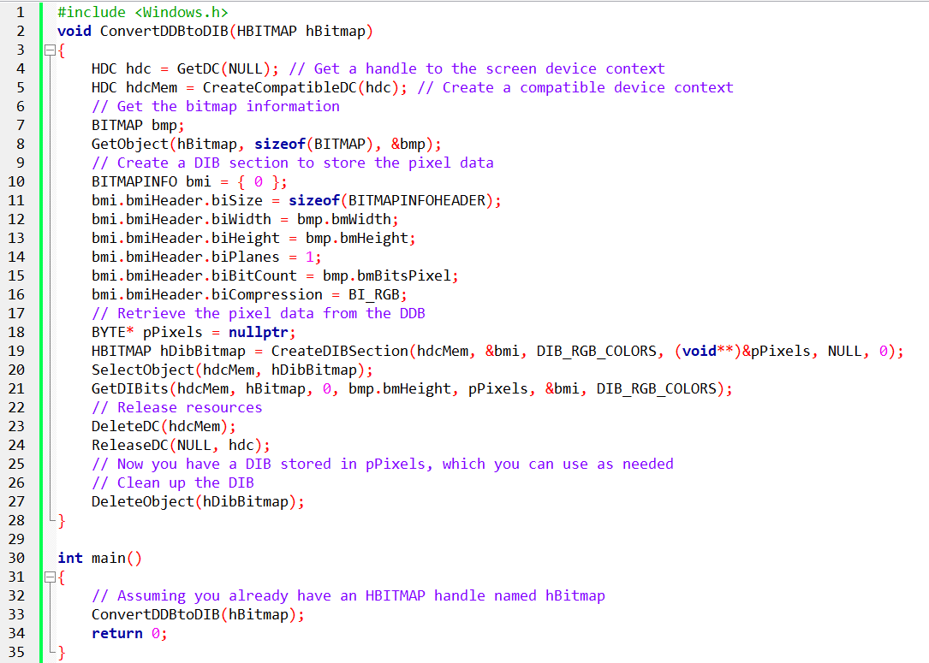

*What are some alternative methods for obtaining the original bitmap data without relying on GetDIBits? Can you provide an example of how the clipboard automatically converts to DIBs? Are there any specific scenarios where the original DIB information is typically unavailable?*

There are alternative methods for obtaining the original bitmap data without relying on GetDIBits. Here are a few:

Directly accessing the bitmap data: If you have access to the original bitmap creation code or the source from which the bitmap was loaded, you can retrieve the pixel data directly from the source without the need for conversion functions. This method ensures that you have the exact original bitmap data.

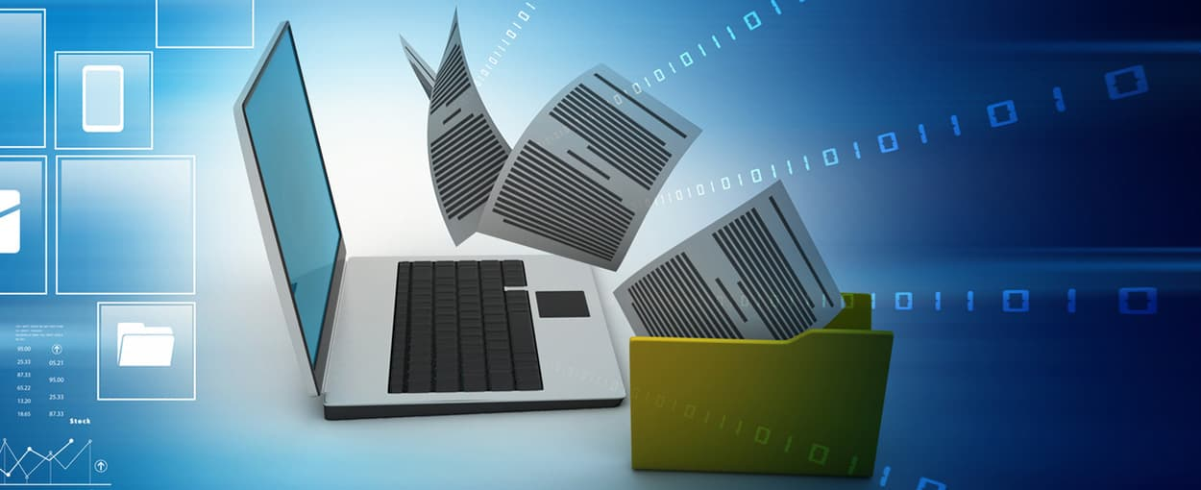

Storing the bitmap data during creation: When creating a bitmap, you can store a copy of the pixel data in a separate buffer or data structure. This way, you have access to the original bitmap data whenever needed, without relying on conversion functions.

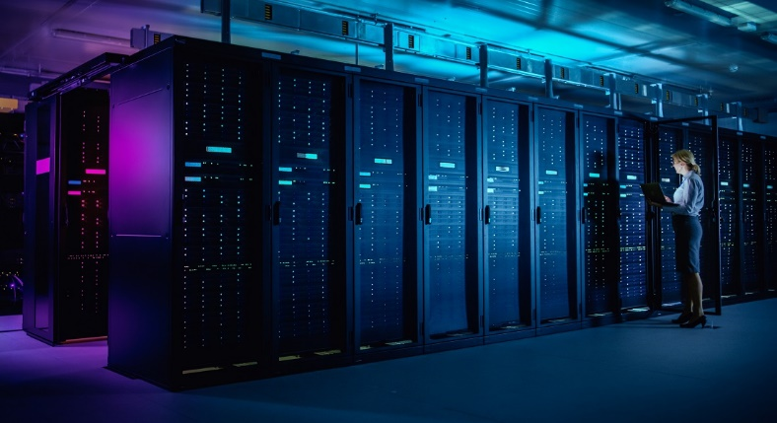

Don’t store it in a server please!!🤣

Serializing and deserializing the bitmap: You can convert the bitmap data into a serialized format (such as a file or a binary stream) during creation. Later, when you need to retrieve the original bitmap data, you can deserialize it back into a bitmap object.



Regarding the automatic conversion of clipboard data to DIBs, when you place a bitmap on the clipboard, Windows automatically converts the bitmap into various formats, including DIBs. When you retrieve the bitmap data from the clipboard, you can request the data in DIB format using the CF_DIB or CF_DIBV5 format identifier. The clipboard API functions, such as OpenClipboard, GetClipboardData, and CloseClipboard, handle the conversion process internally.

There are scenarios where the original DIB information is typically unavailable. Some examples include:

Bitmaps received from external sources: If you receive a bitmap from an external source, such as via network communication, the source may not provide the original DIB information along with the bitmap. In such cases, you may need to rely on conversion functions like GetDIBits to obtain the pixel data and DIB information.

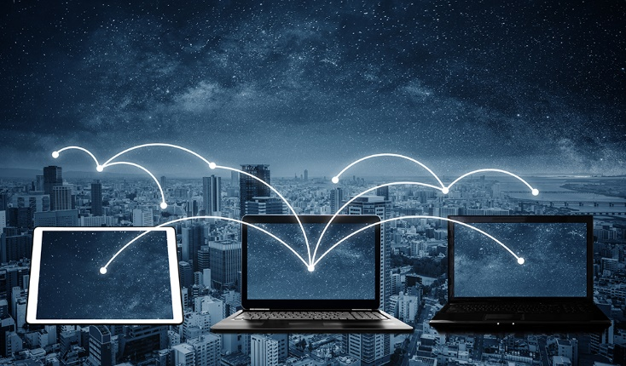

Bitmaps created or modified by third-party libraries or applications: If a bitmap is created or modified by a third-party library or application, the original DIB information may not be accessible to you. In these scenarios, you might need to resort to conversion methods like GetDIBits to retrieve the bitmap data.

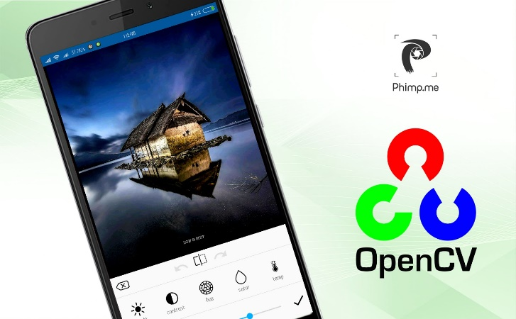

It's important to consider the specific context and requirements of your application to determine the most appropriate method for obtaining the original bitmap data.

*How can I directly access the bitmap data when creating a bitmap? Can you provide an example? Are there any other clipboard format identifiers besides CF_DIB and CF_DIBV5 that can be used to retrieve bitmap data? Explain how the serialization and deserialization process works for bitmap data?*

Direct Access to Bitmap Data in Windows Programming: An Example

In Windows programming, direct access to bitmap data is often facilitated through the use of the GetDIBits and SetDIBits functions. These functions allow you to retrieve and set pixel data for a device-independent bitmap (DIB). Here's a basic example demonstrating how to create a bitmap, directly access its data, and then set it back:

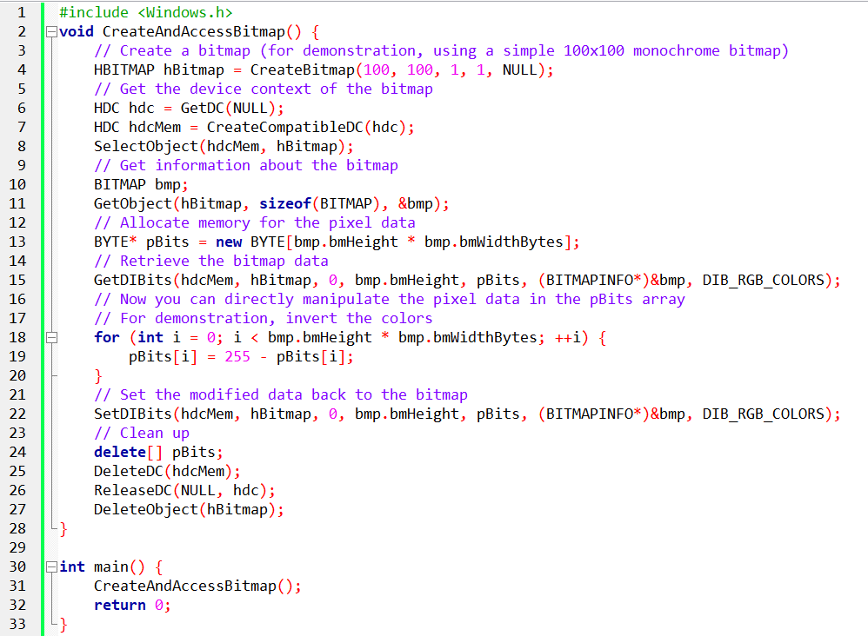

This example creates a monochrome bitmap, retrieves its pixel data using GetDIBits, modifies the data, and then sets it back using SetDIBits. The modification here is a simple inversion of colors for demonstration purposes.

Clipboard Format Identifiers for Bitmap Data:

Besides CF_DIB and CF_DIBV5, other common clipboard format identifiers related to bitmap data include:

* CF_BITMAP: A standard Windows bitmap format.
* CF_PALETTE: A handle to a color palette.

Serialization and Deserialization of Bitmap Data:

Serialization and deserialization of bitmap data involve converting the pixel data into a format suitable for storage or transmission and then reconstructing the bitmap from that serialized data. Common methods include encoding the bitmap as a file (e.g., BMP, PNG, JPEG) or using a custom format for transmission.

For instance, you can serialize a bitmap by saving it to a file:

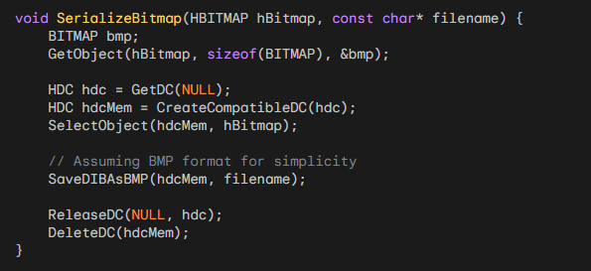

Deserialization involves loading the serialized data back into a bitmap:

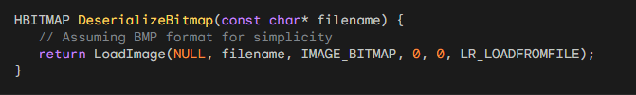

Serialization methods may vary based on the desired format and use case.

UNDERSTANDING DIB SECTIONS:

Understanding CreateDIBSection: A Deep Dive into Bitmap Creation

By now, we've delved into the disparities between device-dependent bitmaps (DDB) and device-independent bitmaps (DIB), appreciating their distinct characteristics and applications.

However, the introduction of CreateDIBSection in 32-bit versions of Windows brings about a function that seems to challenge the established norms. Let's dissect CreateDIBSection and demystify its peculiarities.

Hybrid Bitmap Type: A DIB Section blends aspects of both DDBs (device-dependent bitmaps) and DIBs (device-independent bitmaps).

Memory Access and GDI Handling: It provides direct memory access to pixel data like a DIB, while also being a GDI bitmap object like a DDB.

Creation via CreateDIBSection: This function generates a DIB Section, returning a bitmap handle.

Distinct Features:

Direct Memory Access: You can directly manipulate pixel data in memory, unlike with DDBs.

DIB Handle Flexibility: The handle can be used with GDI functions that typically require DDBs.

Potential Performance Benefits: Direct memory access can lead to performance improvements in certain scenarios.

Key Function Parameters:

pInfo: Pointer to a BITMAPINFO structure defining the DIB's characteristics.

ppBits: Pointer to a pointer variable that will receive the memory address of the pixel bits.

hSection and dwOffset: Optional parameters for sharing memory with other processes (advanced usage).

Usage Steps:

Define Variables: Create variables for BITMAPINFOHEADER, BYTE pointer, and bitmap handle.

Initialize BITMAPINFOHEADER: Set fields like width, height, bit count, and compression.

Call CreateDIBSection: Pass the BITMAPINFOHEADER and ppBits pointer, receiving the bitmap handle and pixel data memory address.

Access Pixel Data: Use the pBits pointer to directly access and manipulate pixel data.

Use Bitmap Handle: Employ the handle with GDI functions as needed.

Differences from CreateDIBitmap:

Handle Type: The handle returned by CreateDIBSection represents a DIB Section, while CreateDIBitmap creates a traditional DDB.

Pixel Data Access: CreateDIBSection offers direct memory access, whereas CreateDIBitmap involves GDI for pixel operations.

Additional Considerations:

Performance: Consider DIB Sections for performance-critical bitmap operations.

Multiple Processes: Use hSection and dwOffset for memory sharing between processes.

Error Handling: Implement error checking for CreateDIBSection calls.

Memory Management: Properly free allocated memory when finished using the DIB Section.

*Let’s go in-depth…*

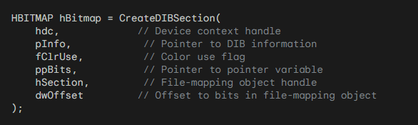

CreateDIBSection, while crucial, may initially appear esoteric due to its unique characteristics. It stands out in bitmap handling functions by creating a "DIB section," essentially a memory block dedicated to storing pixel bits of a bitmap.

Return Value and Bitmap Handle:

The return value, hBitmap, is a handle to a GDI bitmap object. This is where the function deviates from expectations. Despite its similarity in name, CreateDIBSection's return is fundamentally different from other bitmap-creation functions encountered so far.

Simplifying CreateDIBSection:

To simplify its use, you can set the last two arguments, hSection and dwOffset, to NULL and 0, respectively, unless you delve into specific advanced scenarios discussed later.

The hdc parameter is relevant only when fColorUse is set to DIB_PAL_COLORS. If fColorUse is DIB_RGB_COLORS (or 0), hdc is ignored.

In its basic form, CreateDIBSection requires only the second and fourth arguments. The second argument is a pointer to a BITMAPINFO structure.

The fourth argument, ppBits, might seem unusual—it's a pointer to a pointer variable. However, its usage becomes clear when you understand the function's purpose.

Practical Example:

Let's consider a scenario where you want to create a 384×256-bit DIB with 24 bits per pixel.

In this case, the color format is 24-bit, simplifying the structure to a BITMAPINFOHEADER. Initialization involves setting the relevant fields, and then the function is called as follows:

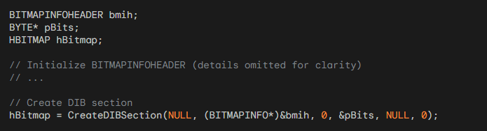

The function examines the structure, allocates memory for the DIB pixel bits, and stores a pointer to this memory block in pBits.

Simultaneously, it returns a handle to the bitmap. Importantly, the bitmap pixel bits are uninitialized at this point and require further handling.

Understanding CreateDIBSection involves recognizing its unique role in creating a dedicated memory section for bitmap pixel bits, a departure from conventional bitmap creation functions.

UNDERSTANDING DIB SECTION CREATION FROM DIB FILE IN DIBSECT.C PROGRAM:

File Loading and Validation:

The function CreateDibSectionFromDibFile is responsible for loading a DIB (Device-Independent Bitmap) file and creating a DIB Section from it. It begins by opening the file using CreateFile, ensuring it has read access and prohibiting write access. The function validates the file format by checking the BITMAPFILEHEADER for the "BM" signature.

Memory Allocation for BITMAPINFO:

The DIB file contains information about the bitmap's characteristics, stored in the BITMAPINFO structure. The function allocates memory for this structure based on the information read from the file. It checks for successful allocation and reads the structure from the file.

DIB Section Creation:

With the BITMAPINFO structure obtained, the function proceeds to create a DIB Section using CreateDIBSection. This function allocates memory for the bitmap pixel bits and returns a handle to the DIB Section. The DIB_RGB_COLORS flag indicates the use of RGB color values in the color table.

Reading Bitmap Bits:

After successfully creating the DIB Section, the function reads the actual bitmap bits from the file and stores them in the allocated memory. The size of the bits is determined by subtracting the offset to the bits (bfOffBits) from the total file size (bfSize).

Cleaning Up:

Finally, the function frees the memory allocated for the BITMAPINFO structure and closes the file handle. The resulting DIB Section handle is returned.

Window Procedure (WndProc) in DIBSECT.C:

File Open Command:

In the window procedure (WndProc), the WM_COMMAND message is handled to respond to user commands. When the "Open" menu item is selected (IDM_FILE_OPEN), the File Open dialog is displayed (GetOpenFileName). If a valid file is chosen, the existing bitmap is deleted, and a new DIB Section is created from the selected file using the previously discussed function.

Painting the Client Area:

In the WM_PAINT message, the program paints the client area by creating a compatible device context (hdcMem) and using BitBlt to transfer the content of the DIB Section to the screen.

Cleanup on Window Close:

When the window is closed (WM_DESTROY), the DIB Section handle is deleted to prevent memory leaks.

The provided code primarily focuses on displaying a loaded BMP file within the application window. However, understanding its underlying functionality can be a valuable foundation for further exploration and customization. Here are some ways you can work with the code beyond merely opening a BMP file:

1. Explore different file formats:

Modify the CreateDibSectionFromDibFile function to handle additional image formats like GIF, PNG, or JPEG by utilizing appropriate libraries or Windows codecs.

Update the file filter string (szFilter) in the OPENFILENAME structure to include relevant extensions for these formats.

2. Implement image manipulation:

Leverage direct access to the bitmap data within the DIB Section to manipulate pixel values.

You can write code to apply filters, modify colors, rotate the image, or perform other image processing operations.

3. Integrate with other functionalities:

Combine this code with other features like image saving, user input handling, or network communication to create more interactive or complex applications.

Develop tools for image editing, basic animation, or image sharing.

4. Further customization:

Modify the window appearance and behavior beyond its current basic structure.

Add UI elements like buttons, sliders, or text boxes for user interaction and control over the displayed image or processing options.

5. Research and learn:

Dive deeper into Windows graphics APIs and image processing libraries to unlock further capabilities and techniques.

Explore resources like MSDN documentation, tutorials, and code examples to expand your knowledge and skillset in working with bitmap data and image manipulation.

In summary, the program allows users to open a DIB file, creates a DIB Section from it, and displays the resulting image in the client area. The handling of file loading, DIB Section creation, and proper cleanup are essential aspects of the implementation.

COMPARISON OF DIBCONV AND DIBSECT FUNCTIONS:

In the analysis of the CreateBitmapObjectFromDibFile function in DIBCONV and the CreateDibSectionFromDibFile function in DIBSECT, distinct differences emerge in their approaches to handling DIB files and creating bitmap objects. Let's delve into the nuanced disparities:

File Reading and Memory Allocation:

DIBCONV (CreateBitmapObjectFromDibFile): Reads the entire file in one step and passes pointers to the DIB memory block to CreateDIBitmap.

DIBSECT (CreateDibSectionFromDibFile): Reads the BITMAPFILEHEADER first, determines the size of the BITMAPINFO structure, allocates memory for it, and then reads it in a second ReadFile call. Passes pointers to the BITMAPINFO structure and the pointer variable pBits to CreateDIBSection.

Memory Ownership and System Control:

DIBCONV: The DIB memory block is implicitly owned by the system as it is handed over to CreateDIBitmap. The system controls the memory.

DIBSECT: The memory block pointed to by pBits is owned by the system. The system automatically frees this memory when the bitmap is deleted using DeleteObject. However, the program retains the capability to alter DIB bits directly through the pBits variable.

Accessing and Modifying DIB Bits:

DIBCONV: The system retains exclusive control over the DIB bits, limiting direct modification by the application.

DIBSECT: The application can use the pointer pBits to directly alter DIB bits, providing a significant advantage in scenarios where manual manipulation of pixel data is necessary.

Format Conversion and Bitmap Handle Differences:

DIBCONV: The format conversion, if needed, occurs during the CreateDIBitmap call.

DIBSECT: The format conversion occurs during subsequent BitBlt or StretchBlt calls. The bitmap handle returned from CreateDIBSection references a DIB stored in system-managed memory that undergoes conversion when displayed.

Handling Bitmap Handle Differences:

DIBCONV: The bitmap handle returned has typical behavior, and any format conversion is mostly handled during creation.

DIBSECT: The bitmap handle from CreateDIBSection references a DIB in system memory with application access. Direct drawing on it reflects changes in the DIB pixel bits through the pBits variable.

Batching GDI Calls and Manual Access:

DIBSECT: When drawing on the memory device context, GDI calls are batched under Windows NT. It's advisable to call GdiFlush after drawing before manually accessing the bits.

Retaining Access to pBits:

DIBSECT: If direct bit manipulation is necessary, retaining the pBits variable is crucial. Once discarded, there seems to be no later way to obtain the bits pointer after the CreateDIBSection call.

In essence, while both functions achieve the creation of bitmap objects from DIB files, DIBCONV relies on CreateDIBitmap for simplicity, DIBSECT, utilizing CreateDIBSection, offers more control over DIB bits and their direct manipulation. The differences in memory ownership and system access highlight the nuanced capabilities of each approach.

Color Organization Discrepancy:

CreateDIBitmap: The bitmap handle shares the color organization with the device specified by the hdc parameter.

CreateDIBSection: The bitmap handle reflects the color organization specified in the BITMAPINFOHEADER structure. Despite this, the handle can be selected into a memory device context compatible with the video display, allowing for versatile usage.

Byte Length Anomaly in Rows:

CreateDIBSection: When using a BITMAPINFOHEADER with 24 bits per pixel and a width of 2 pixels, the bmWidthBytes field obtained from GetObject may not align with the conventional rules. For example, it might be 8 instead of the expected 6. This discrepancy stems from the distinct nature of DIB section handles.

Accessing Bitmap Information with DIBSECTION:

CreateDIBSection: Introduces the DIBSECTION structure, retrievable via GetObject with a specific format:

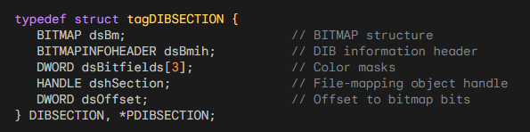

This structure combines both BITMAP and BITMAPINFOHEADER information, providing comprehensive details about the DIB section.

Color Table Access:

CreateDIBSection: Enables extraction of the color table by utilizing the GetDIBColorTable function. This is particularly useful when the DIB section handle is selected into a memory device context. Example:

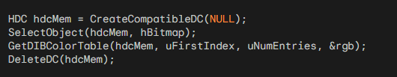

Similarly, modifications to the color table can be achieved using SetDIBColorTable.

In summary, the peculiarities of DIB section bitmap handles, especially those returned from CreateDIBSection, offer a unique blend of color flexibility, information encapsulation through DIBSECTION, and nuanced byte alignment in rows. These features empower developers with greater control and insights into the intricacies of bitmap manipulation and presentation.

FILE-MAPPING APPROACH IN CREATEDIBSECTION: ADDRESSING LIMITATIONS

The concept of file mapping in conjunction with CreateDIBSection is an intriguing avenue for optimizing memory usage, especially for large DIBs.

However, a key limitation arises from the requirement that the offset (dwOffset) within the file mapping object must be a multiple of the size of a DWORD.

Unfortunately, the size of the bitmap file header (BITMAPFILEHEADER) is not always a multiple of 4, leading to complications.

Here is an in-depth exploration of the file-mapping option and its intricacies:

File Mapping Overview:

A file-mapping object treats a file as if it were in memory, allowing efficient access without loading the entire file into RAM.

This approach is particularly beneficial for large DIBs, where the pixel bits can be kept on disk but still accessed as if in memory.

Function Description:

The function CreateDibSectionMappingFromFile attempts to create a DIB section using file mapping and an offset within the file.

It employs CreateFileMapping to establish a file-mapping object, and CreateDIBSection is called with this mapping and the specified offset.

Limitation and DwOffset Constraint:

CreateDIBSection mandates that dwOffset must be a multiple of the size of a DWORD.

The size of the bitmap file header (BITMAPFILEHEADER) is 14 bytes, making bmfh.bfOffBits not always a multiple of 4.

Complication and Resolution:

Due to the non-compliance of bmfh.bfOffBits with the required multiple-of-4 constraint, the straightforward implementation encounters issues.

To address this, a potential solution involves aligning bmfh.bfOffBits to the nearest multiple of 4 before passing it as the dwOffset.

Here is a refined version of the function considering the alignment constraint:

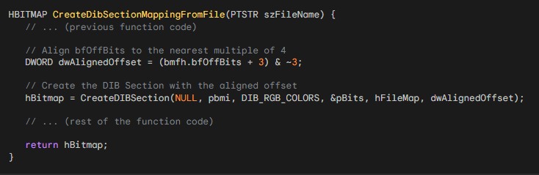

By aligning bmfh.bfOffBits to the nearest multiple of 4 using (bmfh.bfOffBits + 3) & ~3, we adhere to the constraints imposed by CreateDIBSection and improve the likelihood of success in creating a DIB section from a file mapping object.

Key Points:

File-Mapping Option: Allows treating a file as memory-mapped, reducing memory usage for large DIBs.

Challenge for DIB Files: Offset to pixel bits (bfOffBits) within a DIB file isn't guaranteed to be a multiple of 4, as required by CreateDIBSection's dwOffset argument.

Solution: Use a separate file containing only pixel bits, ensuring a DWORD-aligned offset.

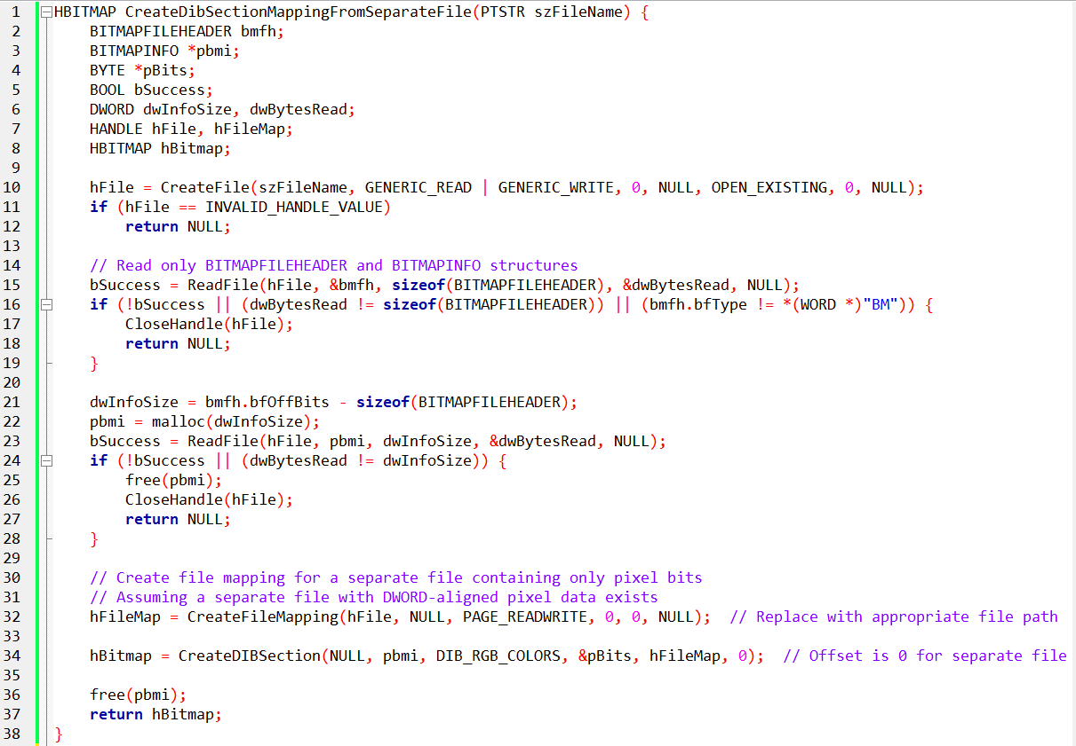

Separate File Preparation: Ensure the separate file containing pixel bits has a DWORD-aligned offset for correct mapping.

Performance: File-mapping might introduce performance overhead, so evaluate its benefits against memory requirements.

Error Handling: Implement robust error handling for file operations and function calls.

Memory Management: Free allocated memory and close handles appropriately.

UNDERSTANDING PERFORMANCE PENALTIES AND ALTERNATIVES FOR ACCESSING DIB PIXEL BITS FROM DISK

1. Potential Performance Penalties:

Utilizing a file-mapping object to access DIB pixel bits from disk introduces potential performance penalties.

Disk I/O operations are inherently slower than memory access, leading to increased latency in reading pixel data.

Large DIBs may result in frequent disk reads, impacting real-time processing and responsiveness.

2. Alternative Methods for Accessing DIB Pixel Bits:

Memory-Mapped Files: Instead of direct file mapping, consider memory-mapped files. This approach allows the operating system to manage caching and paging, potentially improving performance.

Buffered Reading: Implement buffered reading techniques to minimize the number of disk reads. Load portions of the DIB incrementally, reducing the impact on performance.

Code Illustration - Memory-Mapped Files:

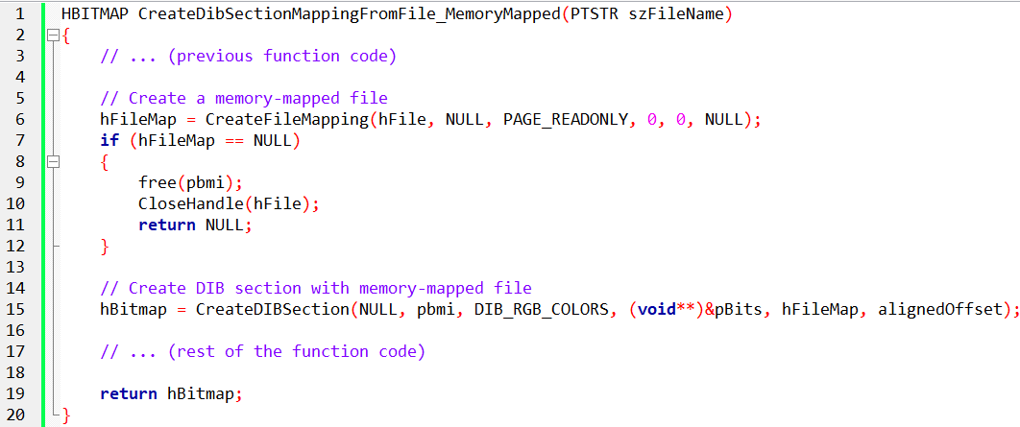

3. Limitations and Considerations:

Alignment Requirement: Ensure proper alignment of the offset to a multiple of 4 to meet CreateDIBSection's constraint.

Memory Usage: Memory-mapping large DIBs may consume substantial virtual memory, affecting overall system performance.

Disk Contention: Concurrent disk access by multiple processes may lead to contention, impacting performance.

File Locking: Consider file locking mechanisms to prevent inconsistencies in multi-process scenarios.

In-Depth Code Explanation:

The modified code aligns the offset to meet CreateDIBSection requirements.

Introduces memory-mapped file usage as an alternative for potential performance improvement.

Addresses considerations related to memory usage, disk contention, and file locking.

By considering alternative methods and being mindful of limitations, you can optimize DIB access from disk while mitigating potential performance penalties.

SUMMARY: CHOOSING THE RIGHT APPROACH FOR DIBS IN WINDOWS PROGRAMMING

When working with Device-Independent Bitmaps (DIBs) in Windows programming, the choice of method depends on the size of the DIB and the desired manipulations. Here's a summary of the approaches discussed:

Small DIBs and Frequent Pixel Manipulations:

Method: Use SetDIBitsToDevice and StretchDIBits for frequent pixel manipulations.

Consideration: Suitable for small DIBs, but performance issues may arise, especially on 8-bit video displays and under Windows NT.

Conversion to DDB (Device-Dependent Bitmap):

Method: Convert a DIB to a DDB using CreateDIBitmap and SetDIBits.

Advantages: Faster display using BitBlt and StretchBlt.

Drawback: No direct access to device-independent pixel bits after conversion.

CreateDIBSection - A Balanced Compromise:

Method: Use CreateDIBSection for a compromise between performance and pixel bit access.

Advantages: Better performance under Windows NT compared to SetDIBitsToDevice and StretchDIBits. Retains access to DIB pixel bits.

Consideration: The bitmap handle references a DIB stored in system-managed memory, allowing direct pixel bit access.

In Conclusion:

For small DIBs with frequent manipulations, SetDIBitsToDevice may suffice but could face performance issues.

Converting to a DDB with CreateDIBitmap provides faster display but sacrifices direct access to pixel bits.

CreateDIBSection strikes a balance, offering good performance under Windows NT, efficient display with BitBlt and StretchBlt, and continued access to DIB pixel bits.

Next Chapter 16:

The exploration of bitmaps will conclude in the next chapter with a focus on the Windows Palette Manager. This will provide a comprehensive understanding of bitmap handling in Windows programming.

*End of Chapter 15…the largest chapter*